**A**

**PROJECT SCHOOL REPORT**

**ON**

**SWASTHYA : Empowering Elder Healthcare and Wellness**

**Submitted By**

**Pragnya Joshi 245322733171**

**Goli Meghana 245322733145**

**Maryada Vineesh Reddy 245322733162**

**Ruttala Nihal 245322733177**

**Kondapally Lasya 245322733087**

**Nakkala Sanjana 245322733100**

**Under the guidance**

**Of**

**Dr. R. Madhavi**

**Assistant professor, CSE (AIML)**



# NEIL GOGTE INSTITUTE OF TECHNOLOGY

Kachavanisingaram Village, Hyderabad, Telangana 500058.

**AUGUST, 2024**



**NEIL GOGTE INSTITUTE OF TECHNOLOGY**

A Unit of Keshav Memorial Technical Education (KMTES)

Approved by AICTE, New Delhi & Affiliated to Osmania University, Hyderabad

**CERTIFICATE**

This is to certify that the project work entitled “SWASTHYA : Empowering elder healthcare” is a bonafide work carried out by “Pragnya Joshi, Goli Meghana, Maryada Vineesh Reddy, Ruttala Nihal, Kondapally Lasya, and Nakkala Sanjana” of II-year IV semester Bachelor of Engineering in CSE during the academic year 2023-2024 and is a record of bonafide work carried out by them.

**Project Mentor**

Dr. R. Madhavi

Assistant Professor

CSE(AIML)

**ABSTRACT**

This project aims to develop a clinical decision support system and disease risk prediction application for Saanjh, a home for the elderly. Elderly populations have unique health needs due to the prevalence of chronic diseases, multiple comorbidities, and the general decline in physical and cognitive functions associated with aging. Timely and accurate health record tracking is crucial for effectively managing these conditions. The application will assist doctors in providing proper treatment by integrating advanced predictive analytics.

Comprehensive health records of the elderly, including medical history, vital signs, lab results, and medication history, will be gathered and our ML model will extract the values. Those values will be compared to the various datapoints in our dataset and the result will be generated.That result will be given to our LLM model.Our LLM model will analyze the result and give detailed analysis of the disease predicted along with diet recommendations and lifestyle changes.

An intuitive application interface will be developed for healthcare professionals to easily input and access health records. The LLM will be integrated into this application to enable robust disease risk prediction and clinical decision support functionalities. Performance analysis will guide iterative improvements, ensuring the application reliably supports doctors in improving elderly care at Saanjh.

**i**

**CONTENTS**

|  |  |  |  |
| --- | --- | --- | --- |
| **S. NO.** | **TITLE** | | **PAGE NO.** |
|  | **ABSTRACT**  **TABLE OF CONTENTS**  **LIST OF FIGURES** | | **i**  **ii**  **iii** |
| **1** | **PROBLEM STATEMENT, INTRODUCTION** | | **1,2** |
| **2** | **LITERATURE SURVEY** | | **3** |
|  | 2.1 | BMC Geriatrics​ ([BioMed Central](https://bmcgeriatr.biomedcentral.com/articles/10.1186/s12877-023-04477-x)) | **3** |
|  | 2.2 | Journal of Medical Ethics​ ([Journal of Medical Ethics](https://jme.bmj.com/content/49/12/838)) | **3** |
|  |  |  |  |
| **3** | **Proposed Work, Architecture, Technology Stack & Implementation Details** | |  |
|  | 3.1  3.2  3.3 | Proposed work  Technology Stack and Architecture  Implementation, Interfaces/APIs used | **4**  **5,6**  **7,8 - 9** |
| **4** | **Results & Discussions** | | **10-38** |
|  | 4.1 | **Elderhome output screens** | **10** |
|  | 4.2 | **Doctor output screens** | **34** |
| **5** | **Conclusion & Future Scope** | | **39,40** |
| **6** | **References** | | **41** |

**LIST OF FIGURES**

|  |  |  |
| --- | --- | --- |
| **Fig. No.** | **Figure Name** | **Page No.** |
| **1.** | **Architecture diagram** | **6** |
|  |  |  |
|  |  |  |
|  |  |  |
|  |  |  |
|  |  |  |
|  |  |  |
|  |  |  |
|  |  |  |
|  |  |  |
|  |  |  |

**iii**

**PROBLEM STATEMENT**

Saanjh is the home for the elderly. The home needs help in tracking the health records of the elderly and predicting any risk for diseases. Create an application that helps the Home to perform a clinical decision support system and disease risk prediction using an existing LLM model. This application should help doctors to give proper treatment.

1. Understand the architecture and capabilities of BERT-based Language Models (LLMs) in natural language processing tasks.

2. Gather health records of the elderly residents, including medical history, vital signs, lab results, medication history, etc.

3. Preprocess the available datasets.

4. Fine-tune LLM with cleaned data using the Multi-Task Learning approach.

5. Verify the fine-tuning process for its quality at each step

6. Design and develop an application interface for doctors and healthcare professionals to input and access the health records of elderly residents.

7. Integrate the fine-tuned LLM model into the application framework for disease risk prediction and clinical decision support.

8. Test the application against evaluation metrics: accuracy, precision, recall, F1-score, and other relevant metrics.

9. Analyze the application's performance in predicting disease risks and providing decision support to doctors.

10. Repeat steps to attain better performance

**­­­ 1**

**INTRODUCTION**

As people get older, their healthcare needs become more complicated and demanding. Elderly individuals often deal with multiple chronic diseases and other health issues, making it essential to closely monitor their health. At Saanjh, a home for the elderly, there's a pressing need for a system that helps keep track of health records accurately and predicts potential health risks. This would assist doctors in making timely and precise medical decisions.

The growing elderly population presents unique healthcare challenges, necessitating innovative solutions to manage their medical needs effectively. The increasing prevalence of chronic conditions among older adults calls for continuous monitoring and timely interventions. Traditional healthcare systems often struggle to provide the personalized and consistent care required for elderly patients, leading to a gap in quality care.

Our project addresses these challenges by integrating advanced technologies such as Machine Learning (ML) and Language Models (LLMs) into a comprehensive elder healthcare management system. Leveraging these technologies, we aim to enhance the accuracy of disease diagnosis, streamline the monitoring of health parameters, and facilitate effective communication between patients, caretakers, and healthcare providers. By harnessing the power of ML and LLM, our system not only supports the daily healthcare needs of elderly individuals but also ensures that they receive timely and appropriate medical attention, thus improving their overall quality of life.

2

**LITERATURE SURVEY**

1. **"Application of Machine Learning in Measurement of Ageing and Geriatric Diseases: A Systematic Review" (2023)** This review examines the use of machine learning in geriatrics and aging research. The study analyzed 70 research articles focused on various geriatric diseases such as diabetes, hypertension, cardiovascular diseases, Alzheimer's, and Parkinson's disease. It highlighted the growing trend of applying ML for predicting biological and brain age, managing chronic conditions, and improving overall elderly care. The review found that most studies reported low risk of bias and showcased the potential of ML in enhancing the quality of life for the elderly by providing early diagnosis and personalized treatment plans.

**Authors**: A.D. and P.D.

**Source**: BMC Geriatrics​ ([BioMed Central](https://bmcgeriatr.biomedcentral.com/articles/10.1186/s12877-023-04477-x))

**DOI** :  <https://doi.org/10.1007/978-981-33-4698-7_1>.

1. **Abstract:**

It is necessary to create an intelligent monitoring system for homes due to the rise in the number of elderly people and those who live alone worldwide. Many older people live alone, but for those with deteriorating cognitive ability, living alone can be challenging, if not deadly. The system includes sensors that can monitor a person's vital signs, sleeping patterns, and mobility. The output readings will be sent to a primary ICE central system, which will use them to look for any anomalies, provide health advice, and even call for assistance if an elderly person is in danger. It will measure the heartbeat, oxygen, temperature, and humidity.

**Published in:**[2023 Second International Conference on Augmented Intelligence and Sustainable Systems (ICAISS)](https://ieeexplore.ieee.org/xpl/conhome/10250420/proceeding)

**DOI:**[10.1109/ICAISS58487.2023.10250703](https://doi.org/10.1109/ICAISS58487.2023.10250703)

**3**

**PROPOSED WORK**

Our proposed system is designed to cater to two users:

Elder Home and Doctor. Here’s a breakdown of how each user can effectively utilize our portal.

1. Elder Home : The Elder Home side is used by the caretakers of the elder home. A caretaker will be assigned to every few elder home residents and all their needs are taken care of by the caretaker. The proposed work for this user is that all elderly resident’s caretakers will have an access to upload the test reports of the elders and should be able to get the result of the report and should be able to get the analysis of the result and get some good diet recommendations and lifestyle changes recommendations.
2. Doctor : The doctor side is used by the doctor who is associated with the Elder Home. He/she must be able to view the reports uploaded by the elder side and be able to get some assistance from the LLM regarding the report result.

**4**

**TECHNOLOGY STACK**

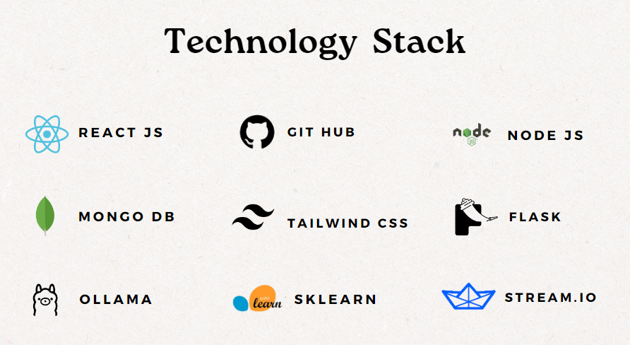

1. React Js : ReactJs is one of the JavaScript frameworks used for frontend.
2. NodeJs : a framework of JavaScript used for backend.
3. MongoDB : This is used for storing data, retrieving data, and manipulating data of all the users of the application.(Used as a database).
4. Tailwind CSS : Used for styling the webpages.
5. Flask : Flask is a Python web framework which is used as the LLM Server.
6. Ollama : Ollama is the platform from which our LLM model GEMMA2 is downloaded.
7. SKLearn : This is a python library from which we implemented our ML Model Random Forest Classsifier.
8. Stream.io : Our application integrates a third-party video call application using Stream SDK to facilitate real-time video consultations between users. This feature is particularly useful for remote consultations, providing a seamless and reliable video communication experience. 5

**ARCHITECTURE**

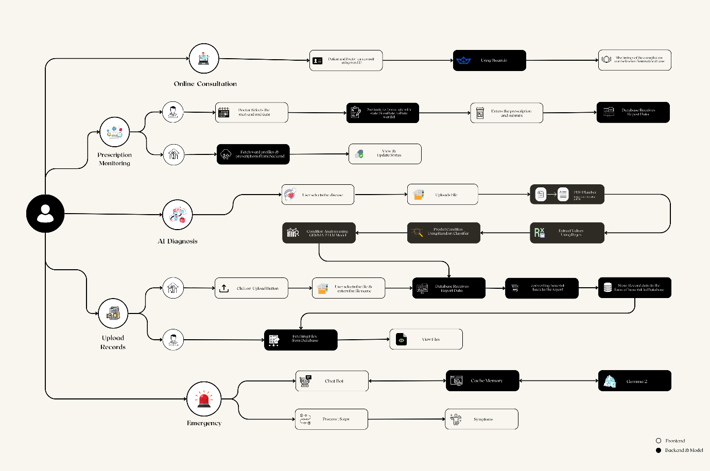

**6**

**IMPLEMENTATION**

1. Elder home : The caretakers must initially signup by going to the get started page . The user then has to signup by filling in their details. After successfully signing up, they can login using the same credentials. After logging in the user can either 1) register a new ward profile or 2) view the created ward profiles.

When the user chooses register a new ward option, they should fill out details about the patient, guardian and the caretaker assigned for the particular patient. The ward profiles page contains all the pre-registered wards.Each ward profile will have a ward ID. In the dashboard, the user can upload the general details like height, weight, Blood pressure details, pulse rate and body temperature, and when all these are submitted, the body mass index , blood pressure details, temperature are displayed. The user can navigate through the sidebar. The sidebar contains features like uploading the patient’s health records, viewing the previously uploaded records, Prescription monitoring, AI diagnosis, video consultation, and Emergency.

* Upload Records : The caretaker can upload the health reports of the patient.
* View Records : The uploaded records can be viewed.
* Prescription Monitoring : The prescription which is uploaded by the doctor will be seen here.The list of medicines along with the time restrictions will be given by the doctor. Every medicine in the prescription will have a submit button. After the patient takes the medicine, the caretaker can click on the submit button to mark that the patient has taken that medicine, and this can be reset everyday.This helps in monitoring the prescription of the patient.
* AI Diagnosis : This page takes the reports of the patient. There are 5 disease detections : Diabetes, Anemia, Blood Report, Kidney Functionality, and Thyroid. The user can choose any of the disease, and upload the report. After the record has been uploaded, Our ML model extracts the values from the report and compares those values with the datapoints present and the result generated is shown.
* Video Consultation : This feature allows communication between the patient and the doctor. This is a very useful feature as the elderly people might not be able to travel due to certain circumstances or disabilities. The patient and the doctor should join from a particular ward profile, and they will be connected automatically.
* Emergency : The emergency feature contains a few first-aid support. It contains the symptoms, the process to give first aid and a video to refer to carry out the procedures if required. We have included five most frequently faced emergency conditions : CPR, Dysartharia, Seizures, Fainting, and Shortness of breath.

2) Doctor : The doctor must initially signup by going to the get started page. After signup, the doctor has to login using the same credentials. After successfully logging in, the doctor will be able to view all the patient profiles. When the doctor selects a profile, the doctor will be able to see the general details, i.e, the height, weight, body mass index, blood pressure values, temperature of the patient entered by the respective patient.The sidebar has the following features : 1) Prescription uploading, 2) Viewing records uploaded by the patient, 3) Record archives, 4) Consultation.

* Prescription uploading : The doctor can upload the required prescription which can be viewed by the patient on the elderhome side. The doctor can choose the duration of the prescription and can upload the medicine names, the time at which the medicine is to be taken, the amount (in gms) can be uploaded.
* Viewing records : The doctor will be able to view the reports uploaded by the elderhome side.
* Record archives : The archived records of the previously stored results retrieved by the LLM and ML model are stored here for future reference or use.
* Video Consultation : This feature allows communication between the patient and the doctor. This is a very useful feature as the elderly people might not be able to travel due to certain circumstances or disabilities. The patient and the doctor should join from a particular ward profile, and they will be connected automatically.

8

**INTERFACES/APIs and MODELS USED**

1. LLM model: Gemma2 API running on Ollama server
2. Stream.io is a third-party software application used for video consultation
3. Machine Learning model: Random Forest Classifier

9

**RESULTS**

1. **Home/landing page**

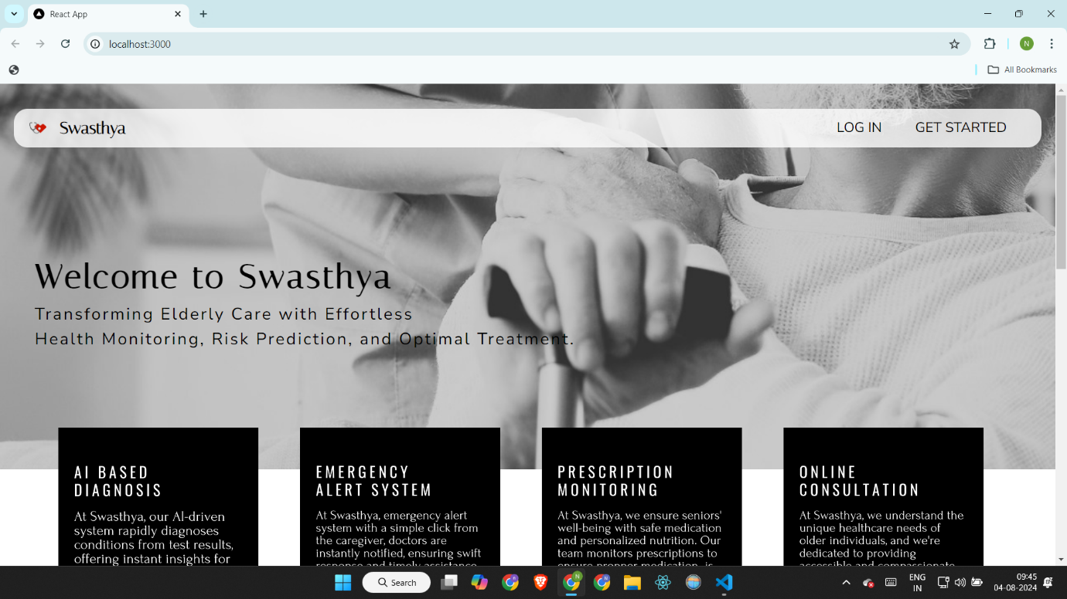

1. **FAQs Page**

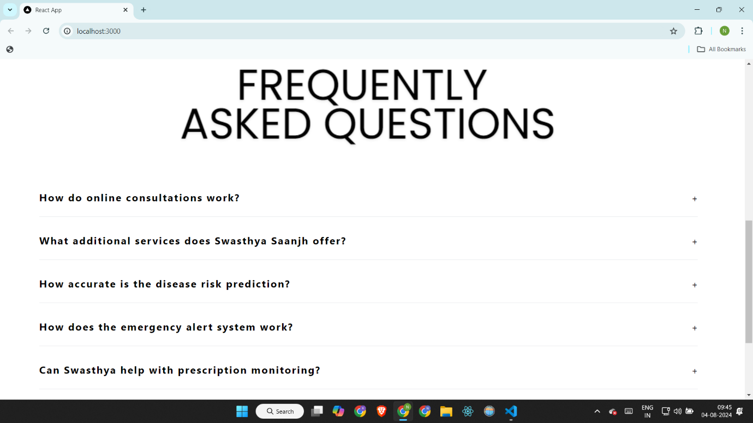

10

1. **Signup cards**

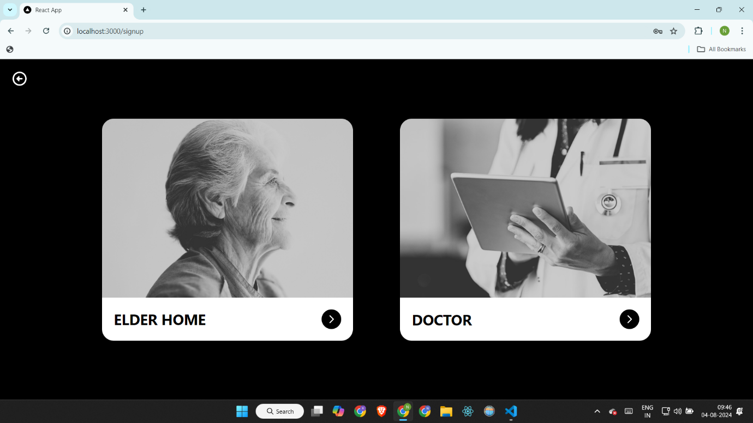

1. **Elderhome signup**

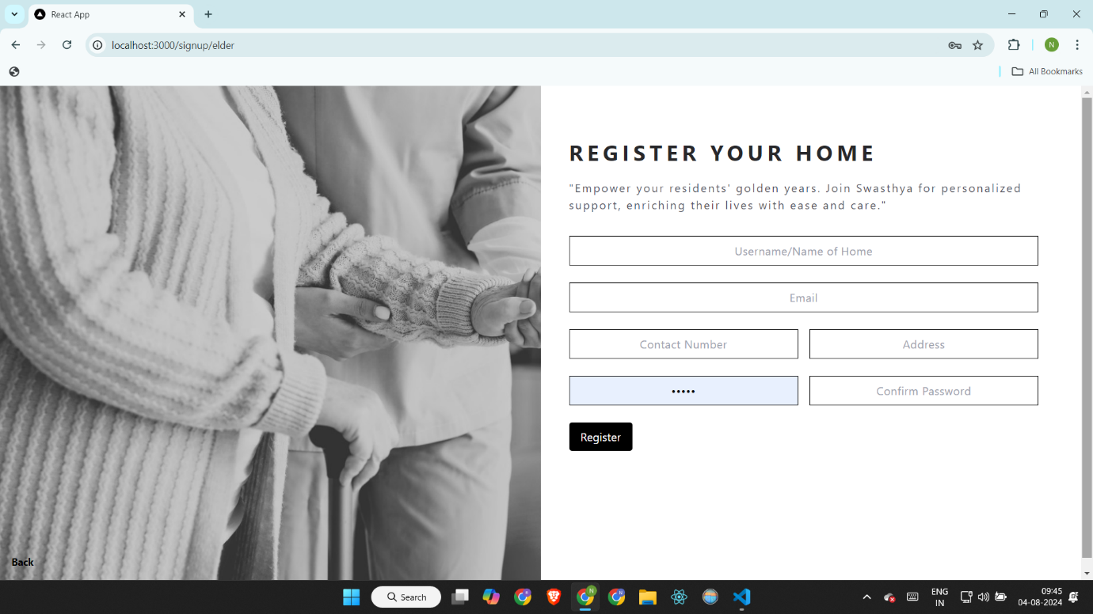

**11**

1. **Doctor signup**

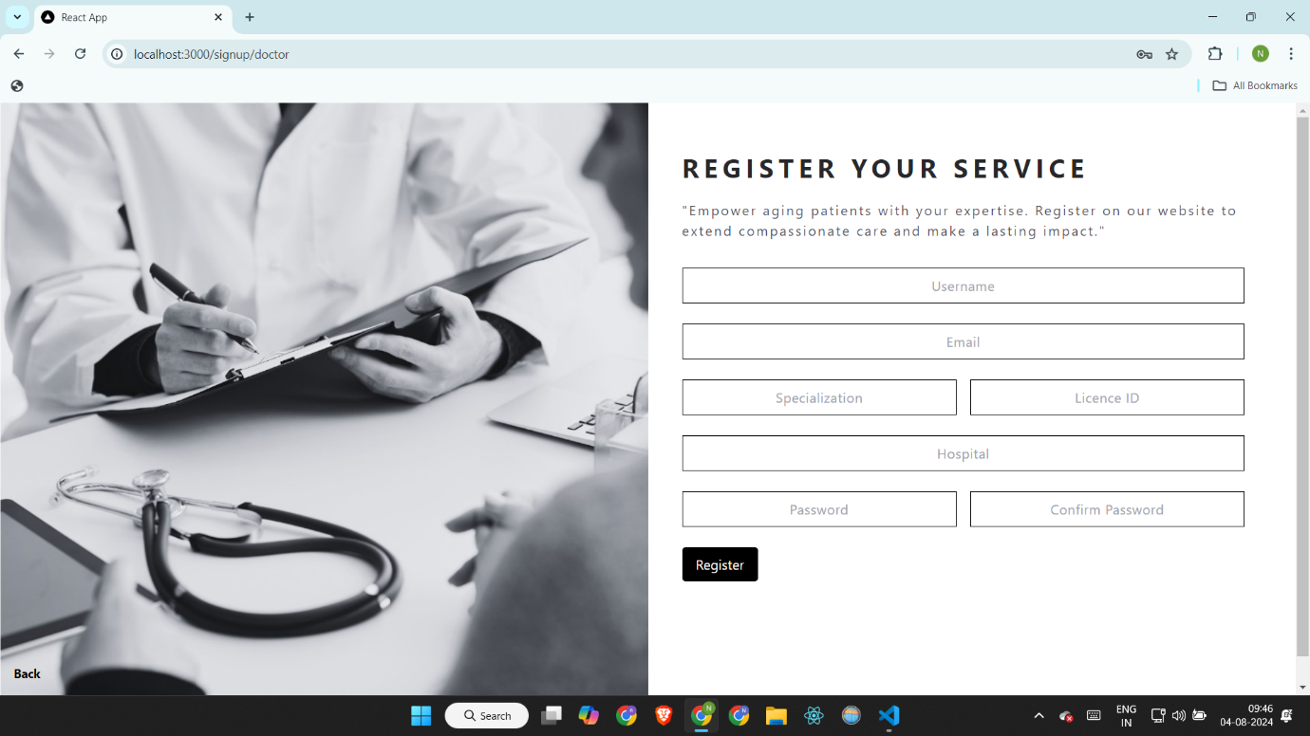

1. **Login cards**

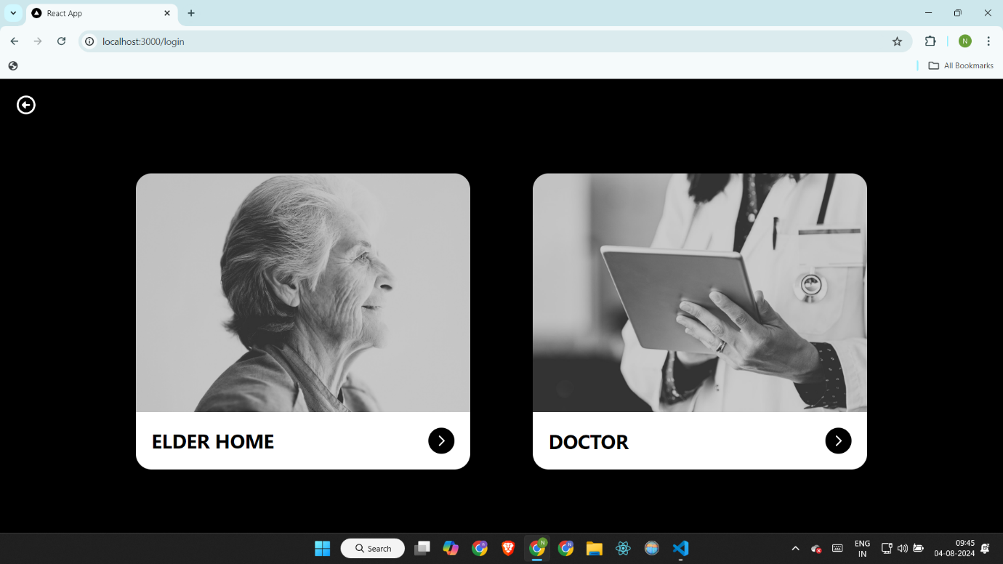

**12**

1. **Elderhome login**

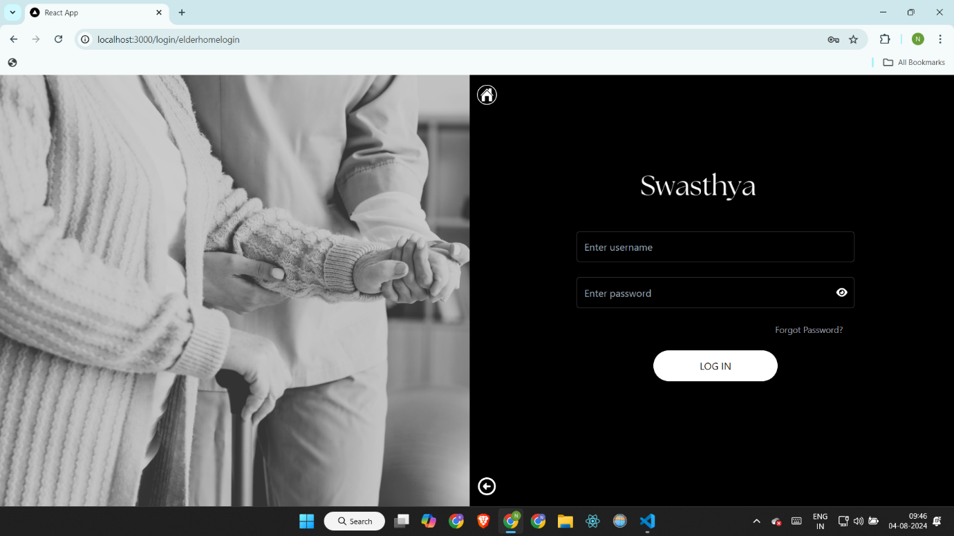

1. **Doctor login**

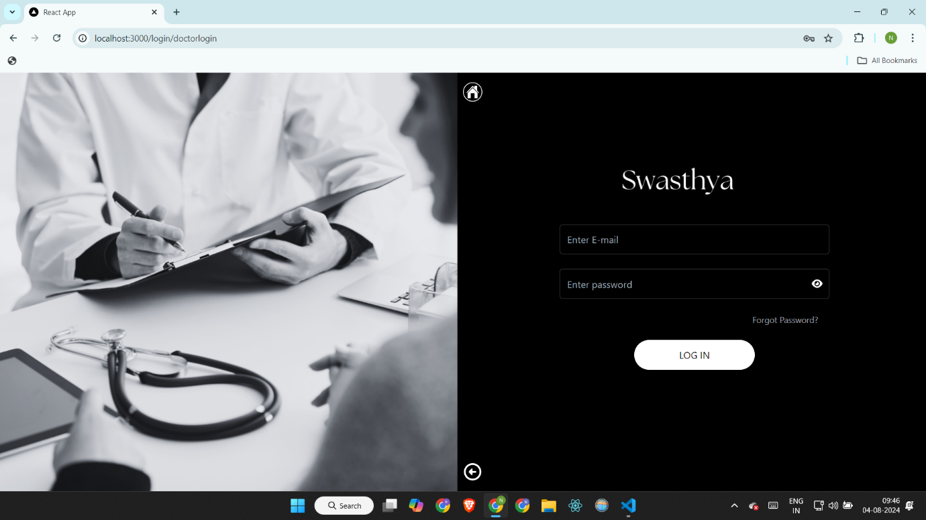

**13**

1. **After elder home login**

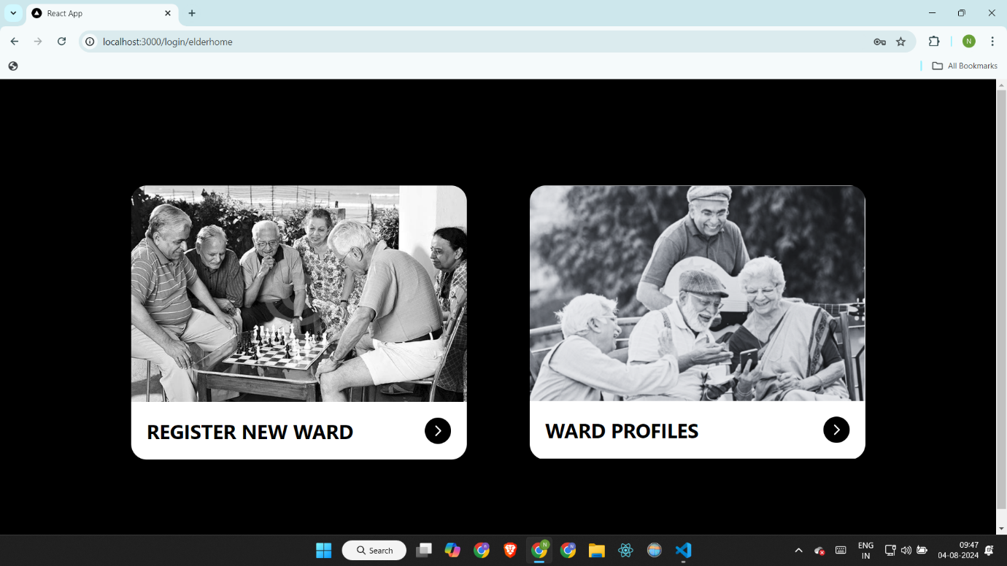

1. **Register new ward : Ward registration**

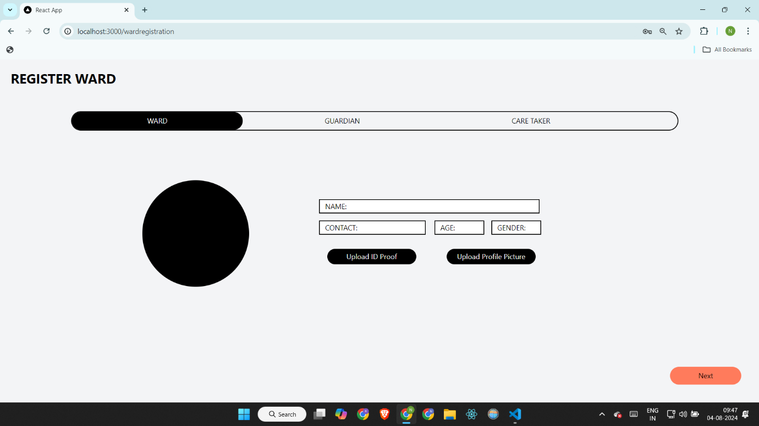

14

1. **Guardian registration**

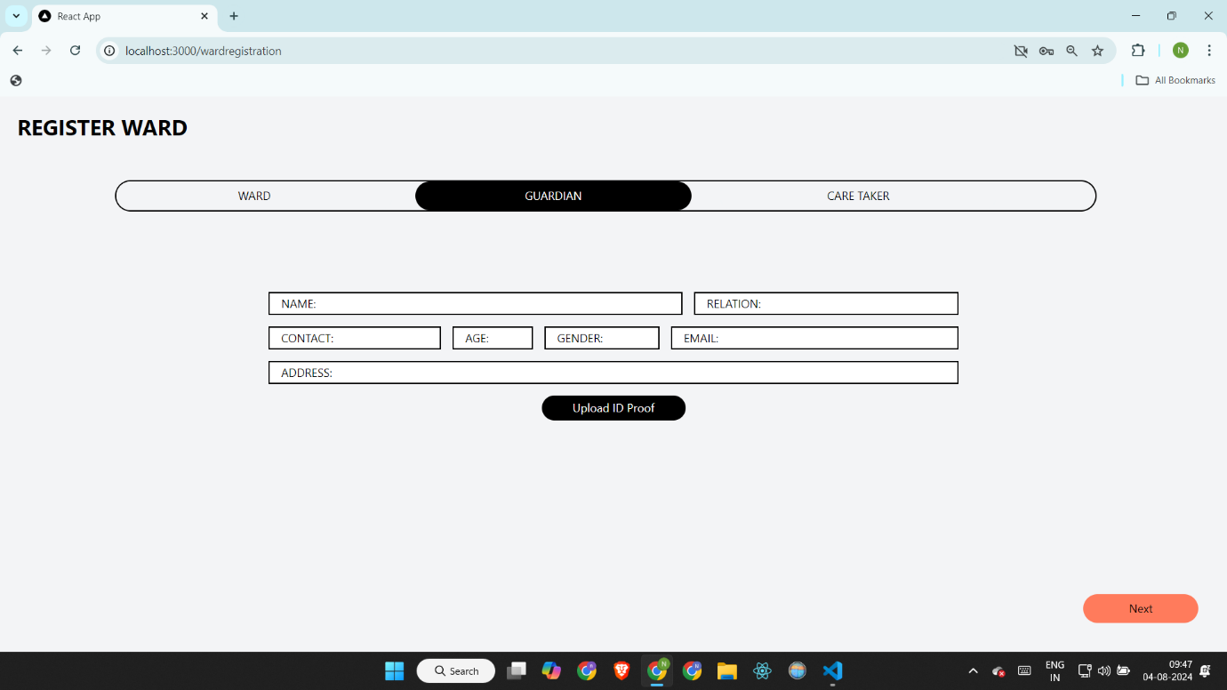

1. **Caretaker registration**

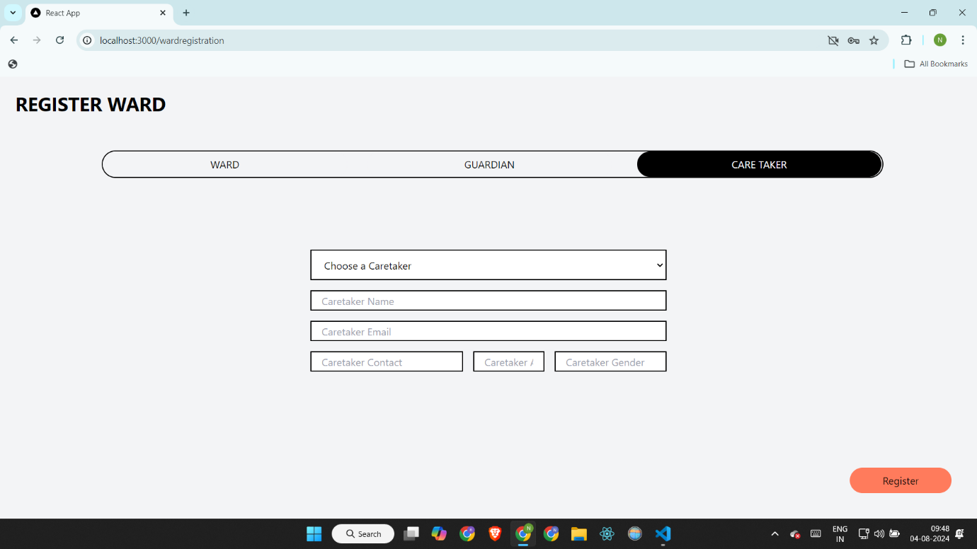

**15**

1. **Ward profiles**

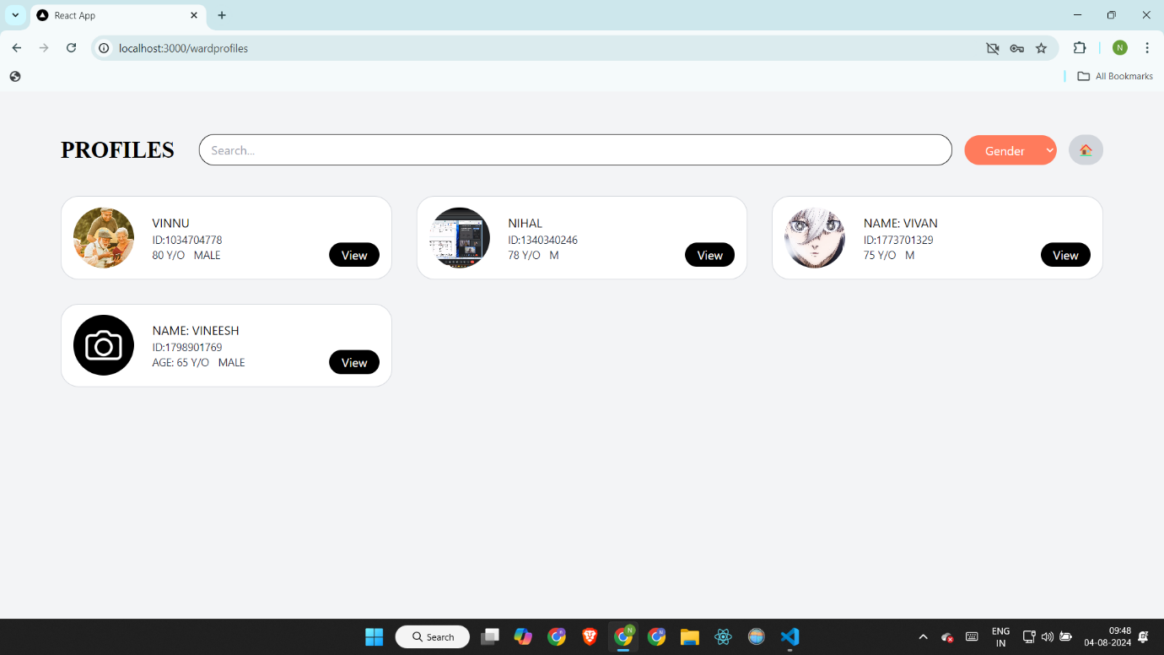

1. **Dashboard**

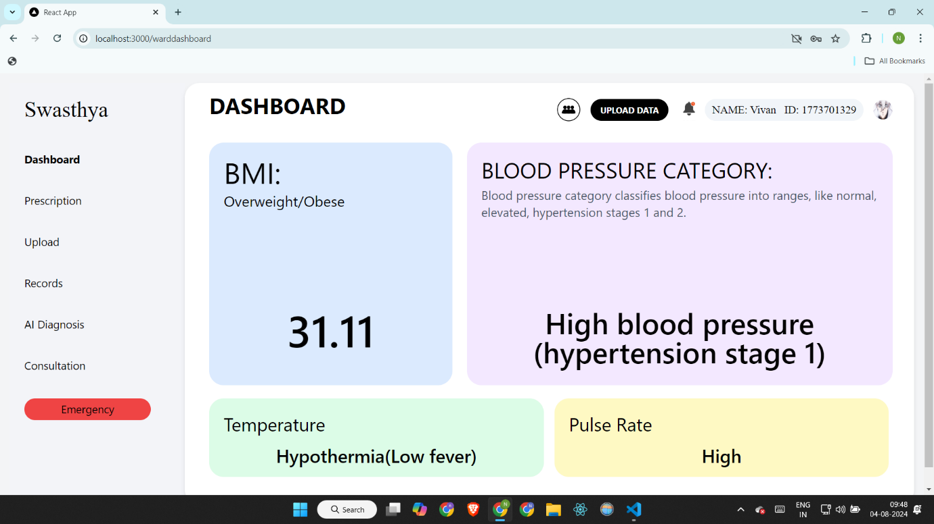

**16**

1. **General Checkup**

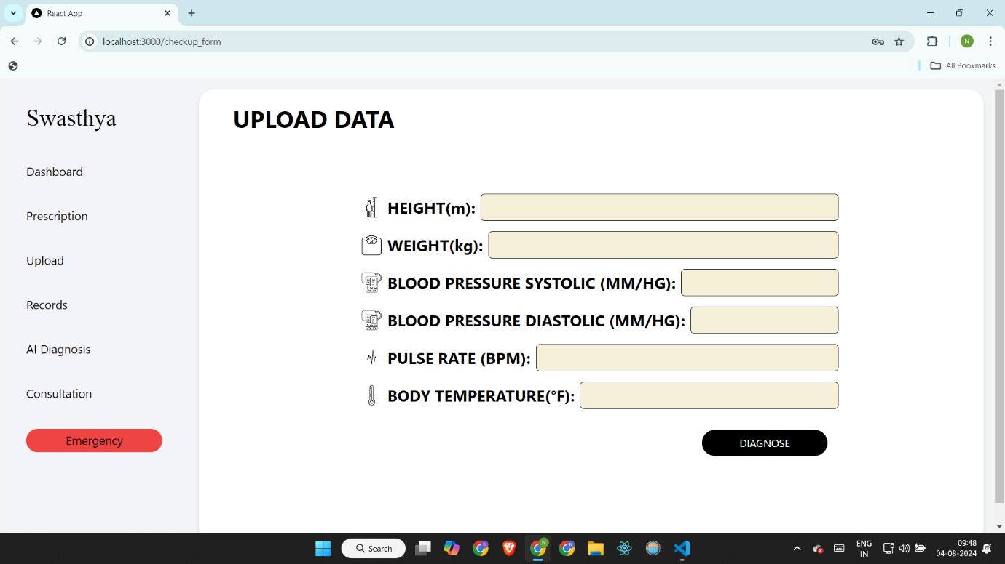

1. **Notifications from doctor**

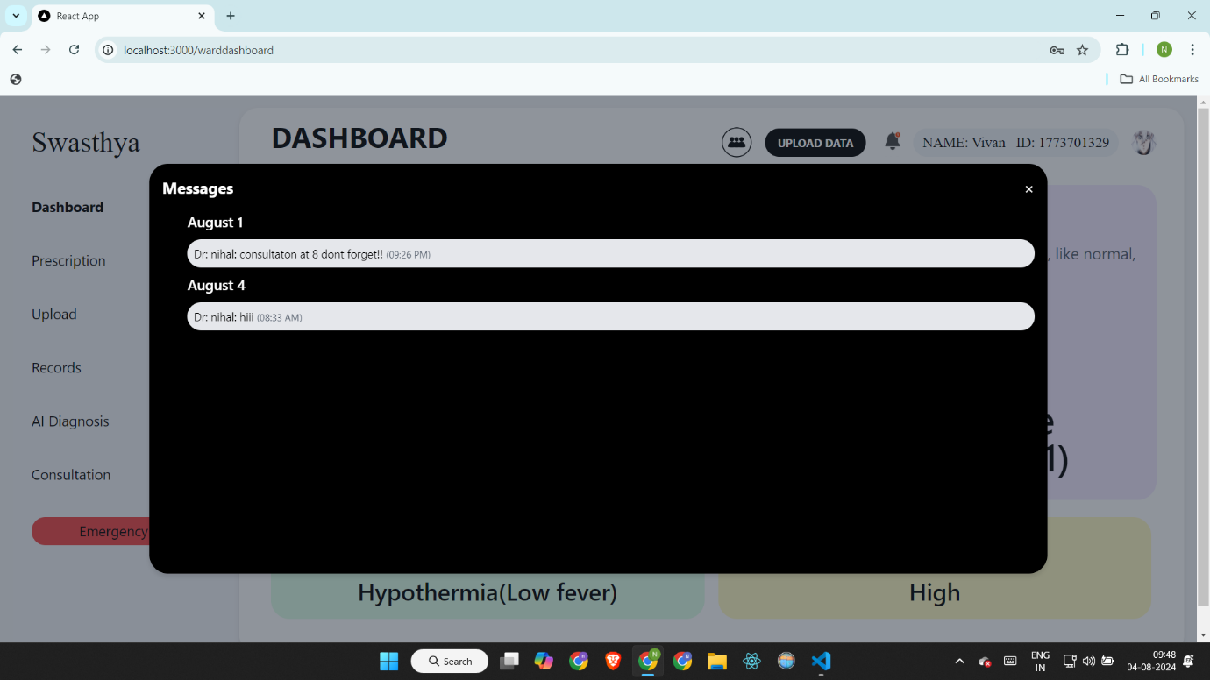

**17**

1. **Prescription**

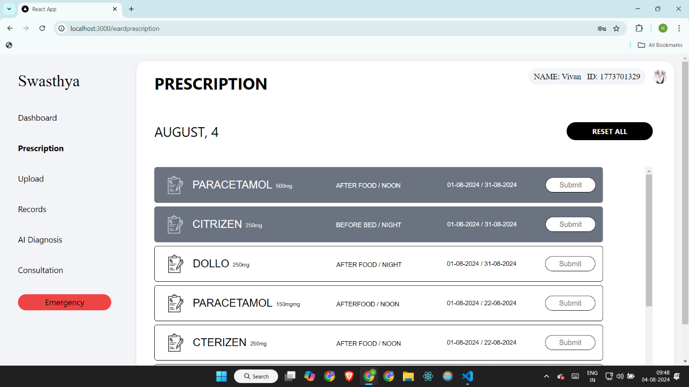

1. **Upload Reports/records**

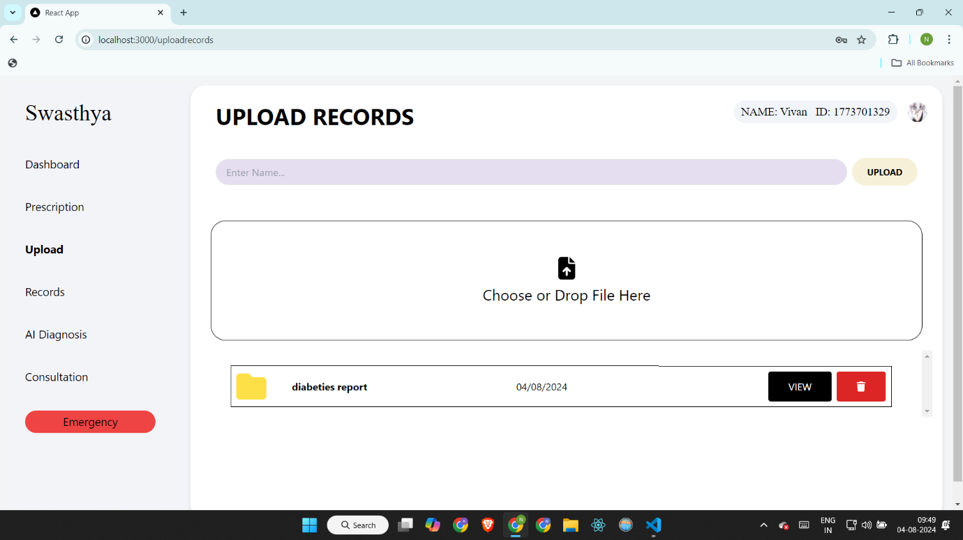

**18**

1. **View uploaded reports**

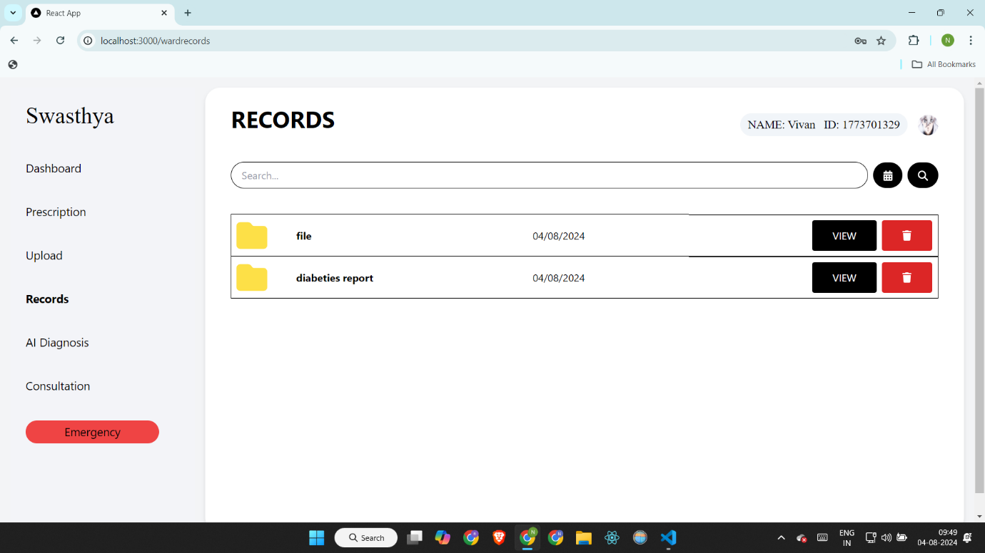

1. **AI Diagnosis choose report type**

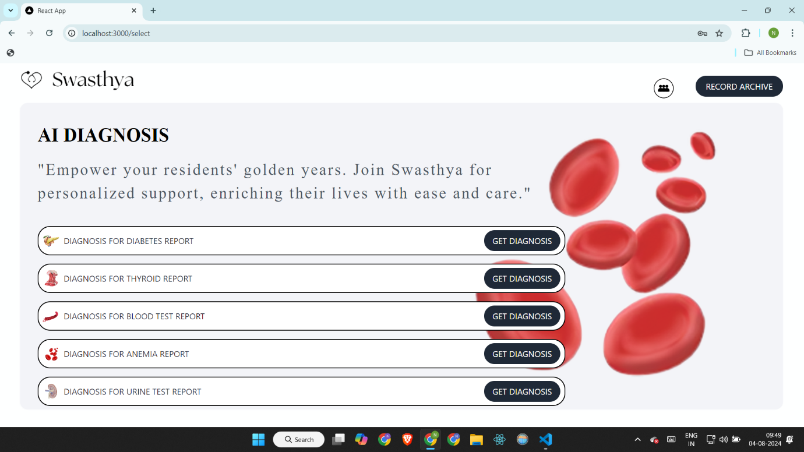

**19**

**21. Diabetes**

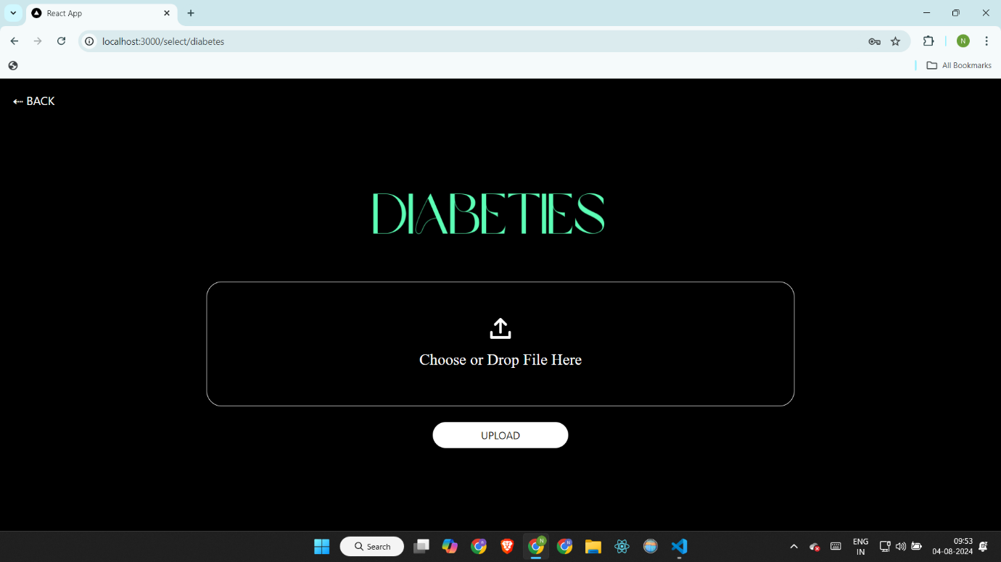

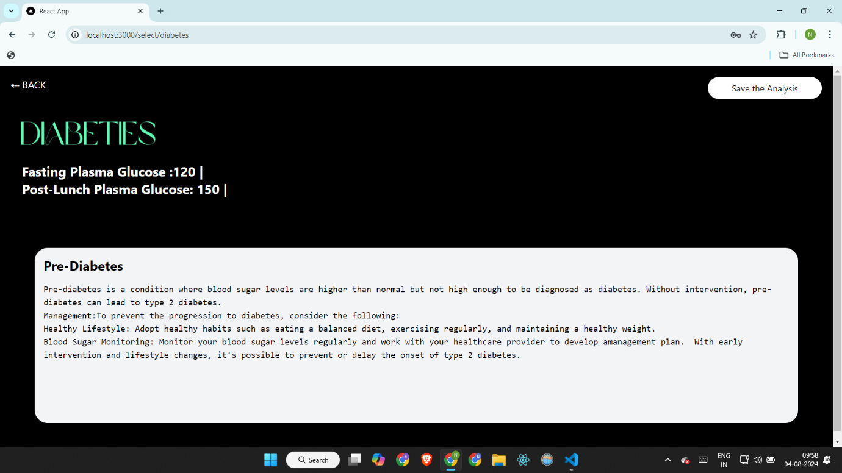

**20**

**22. Thyroid**

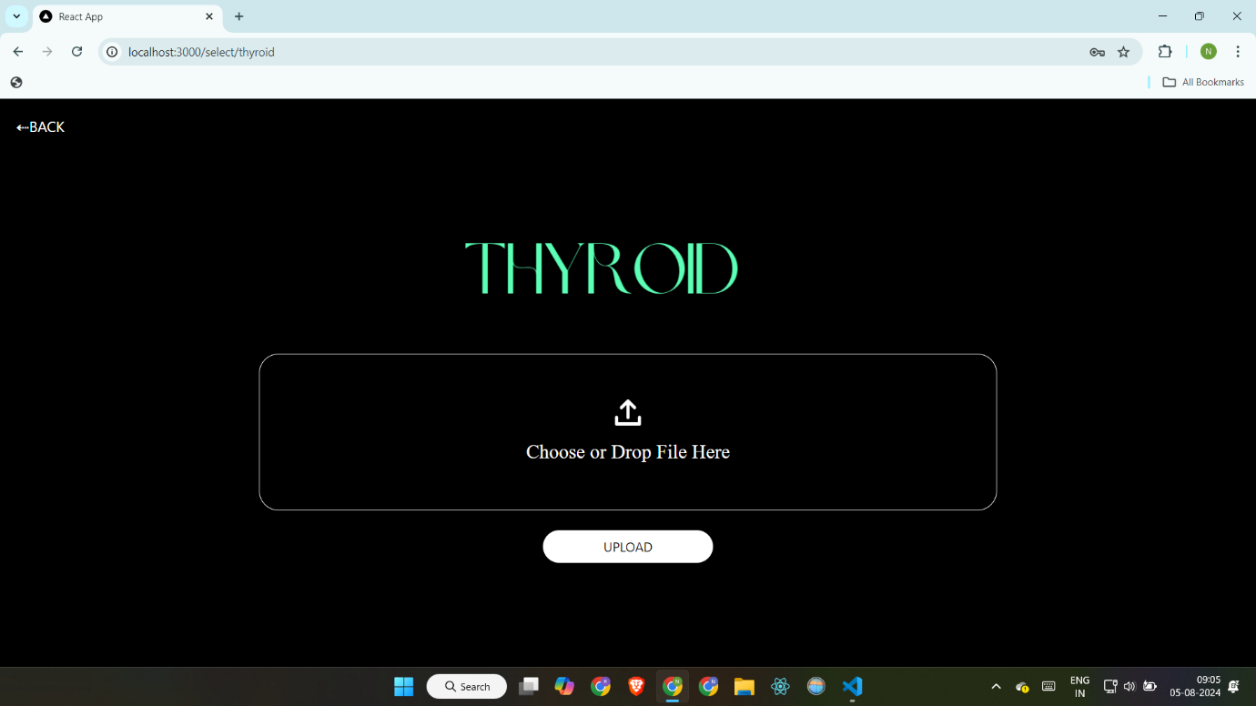

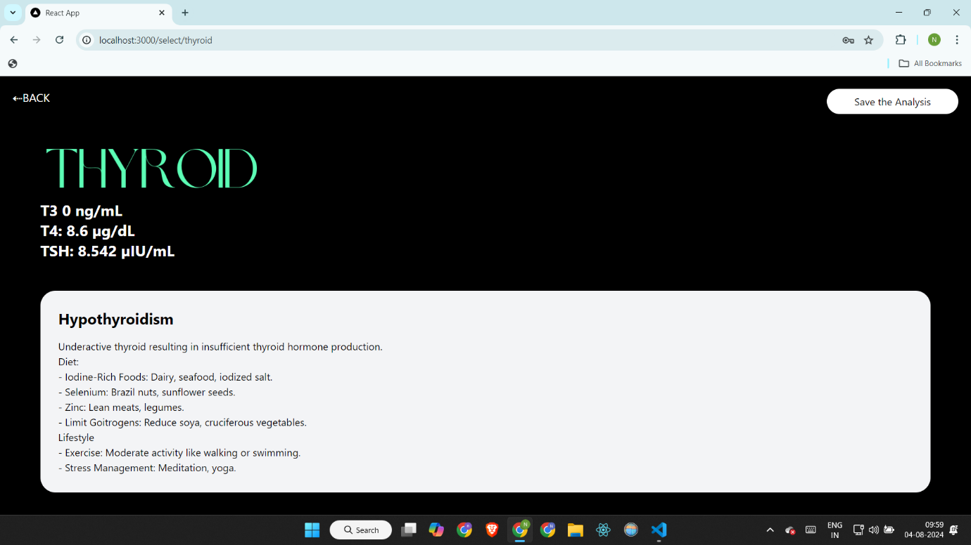

**21**

**23. Blood Test**

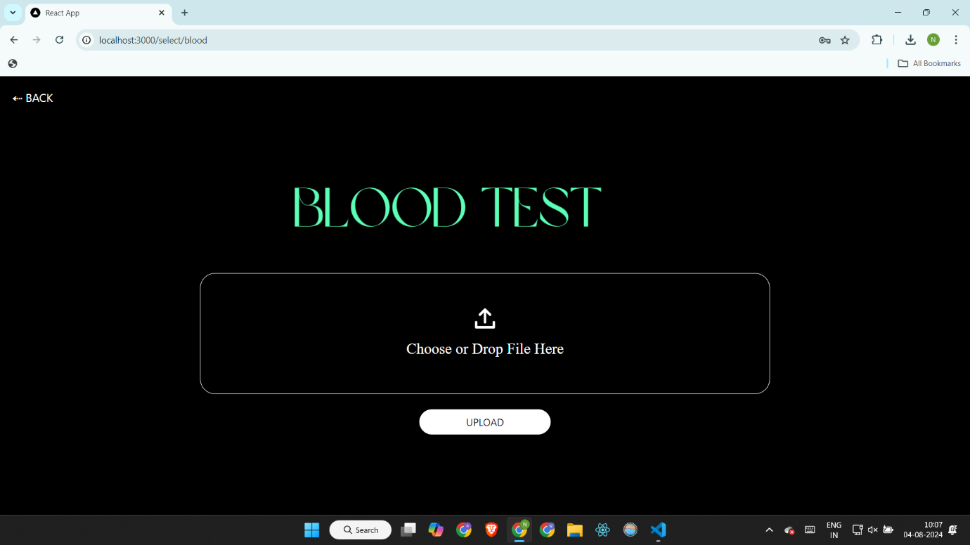

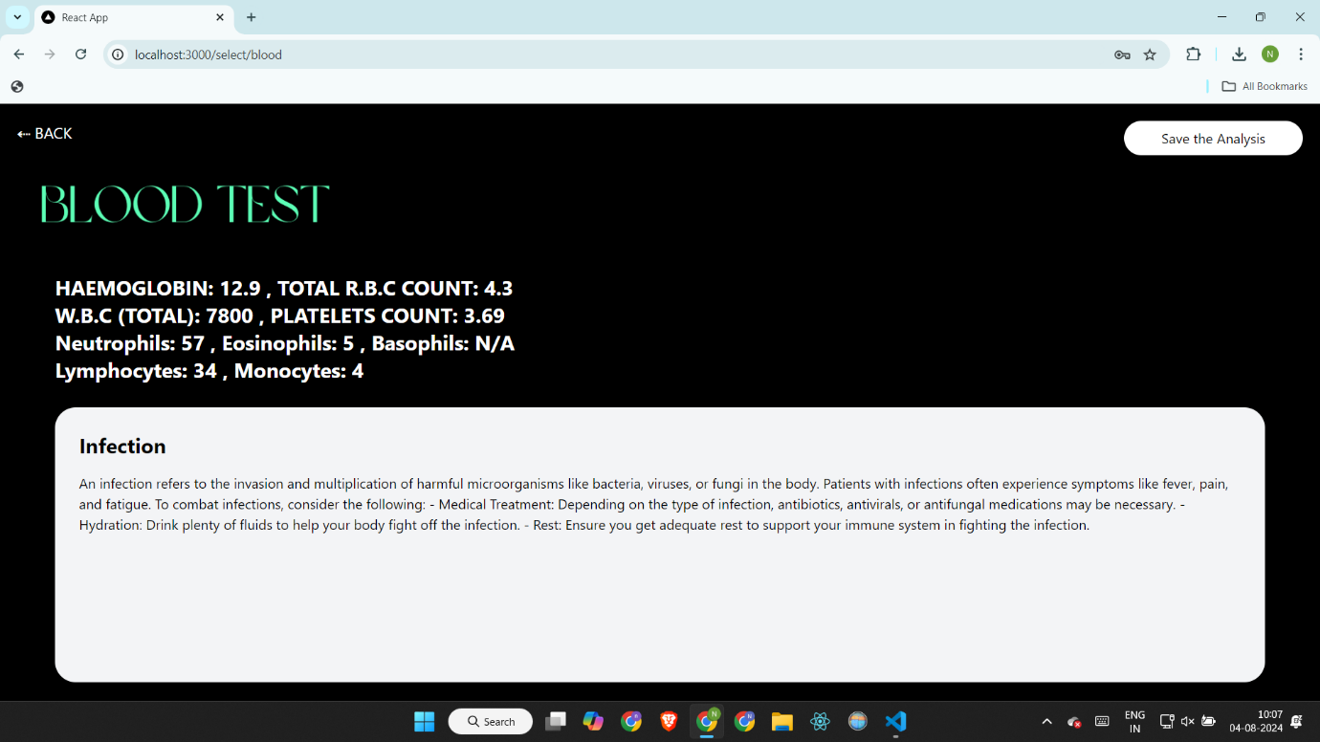

**22**

**24. Anemia**

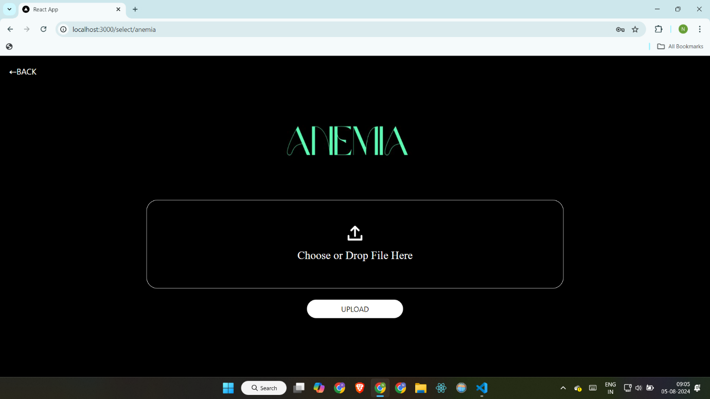

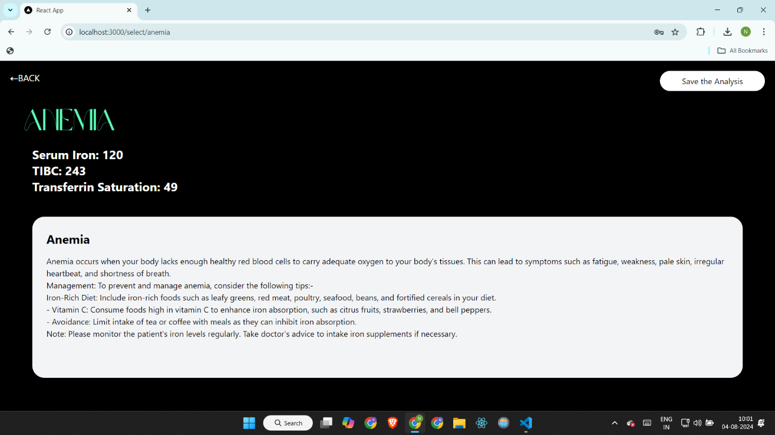

**23**

**25. Urine Test**

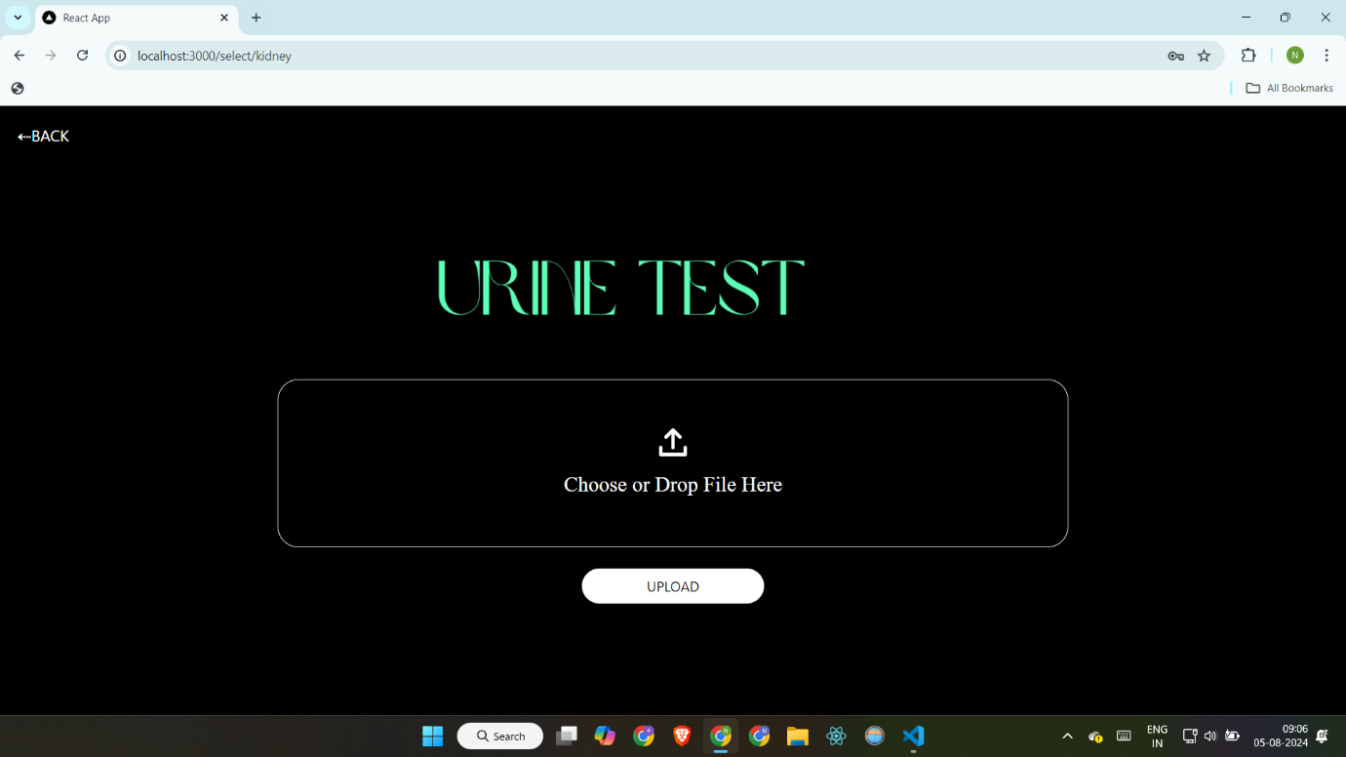

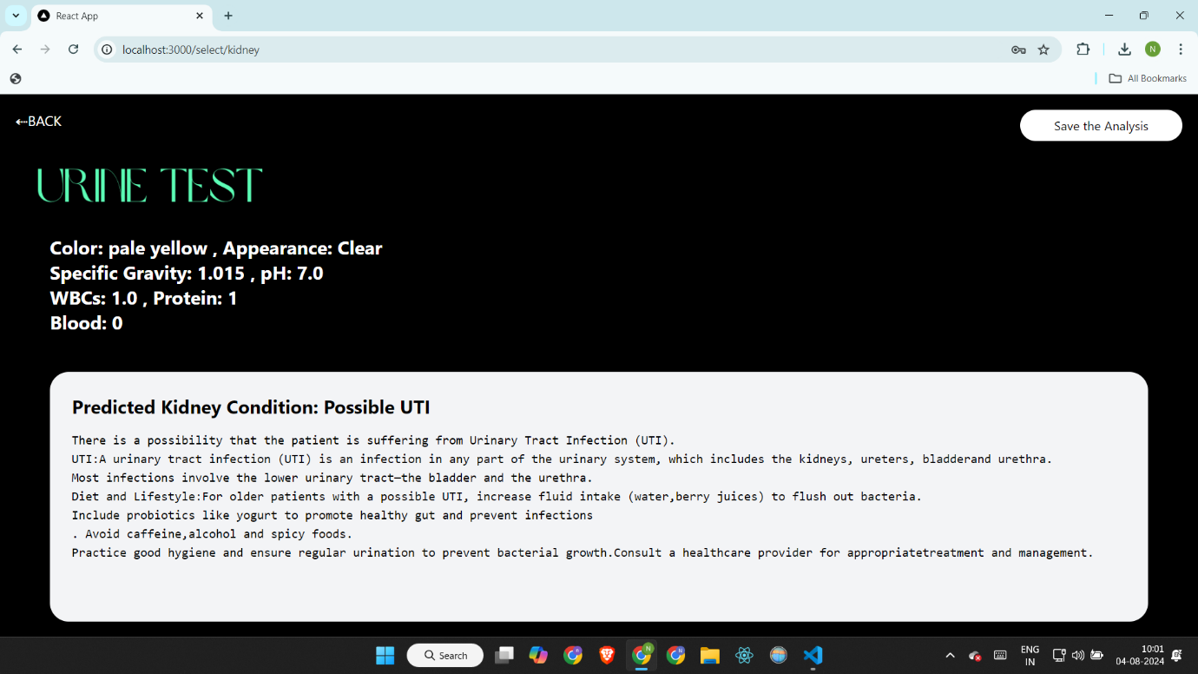

**24**

**26. Consultation**

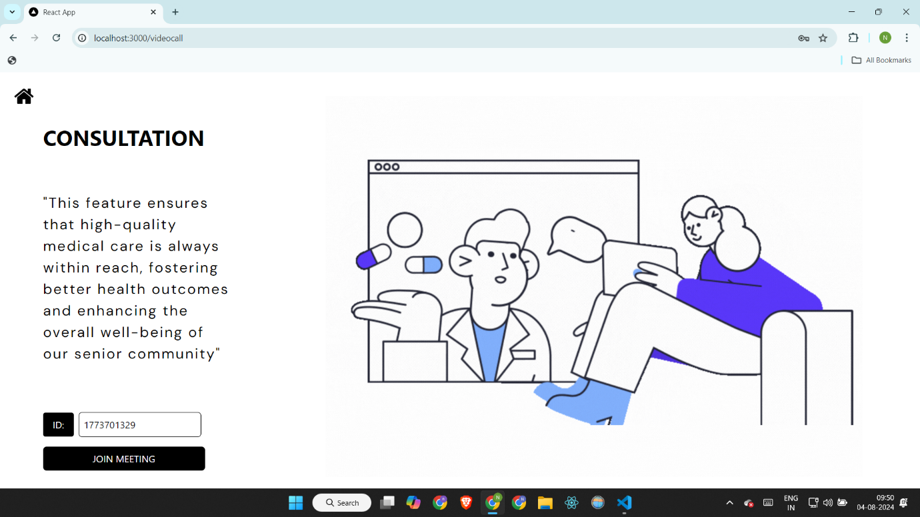

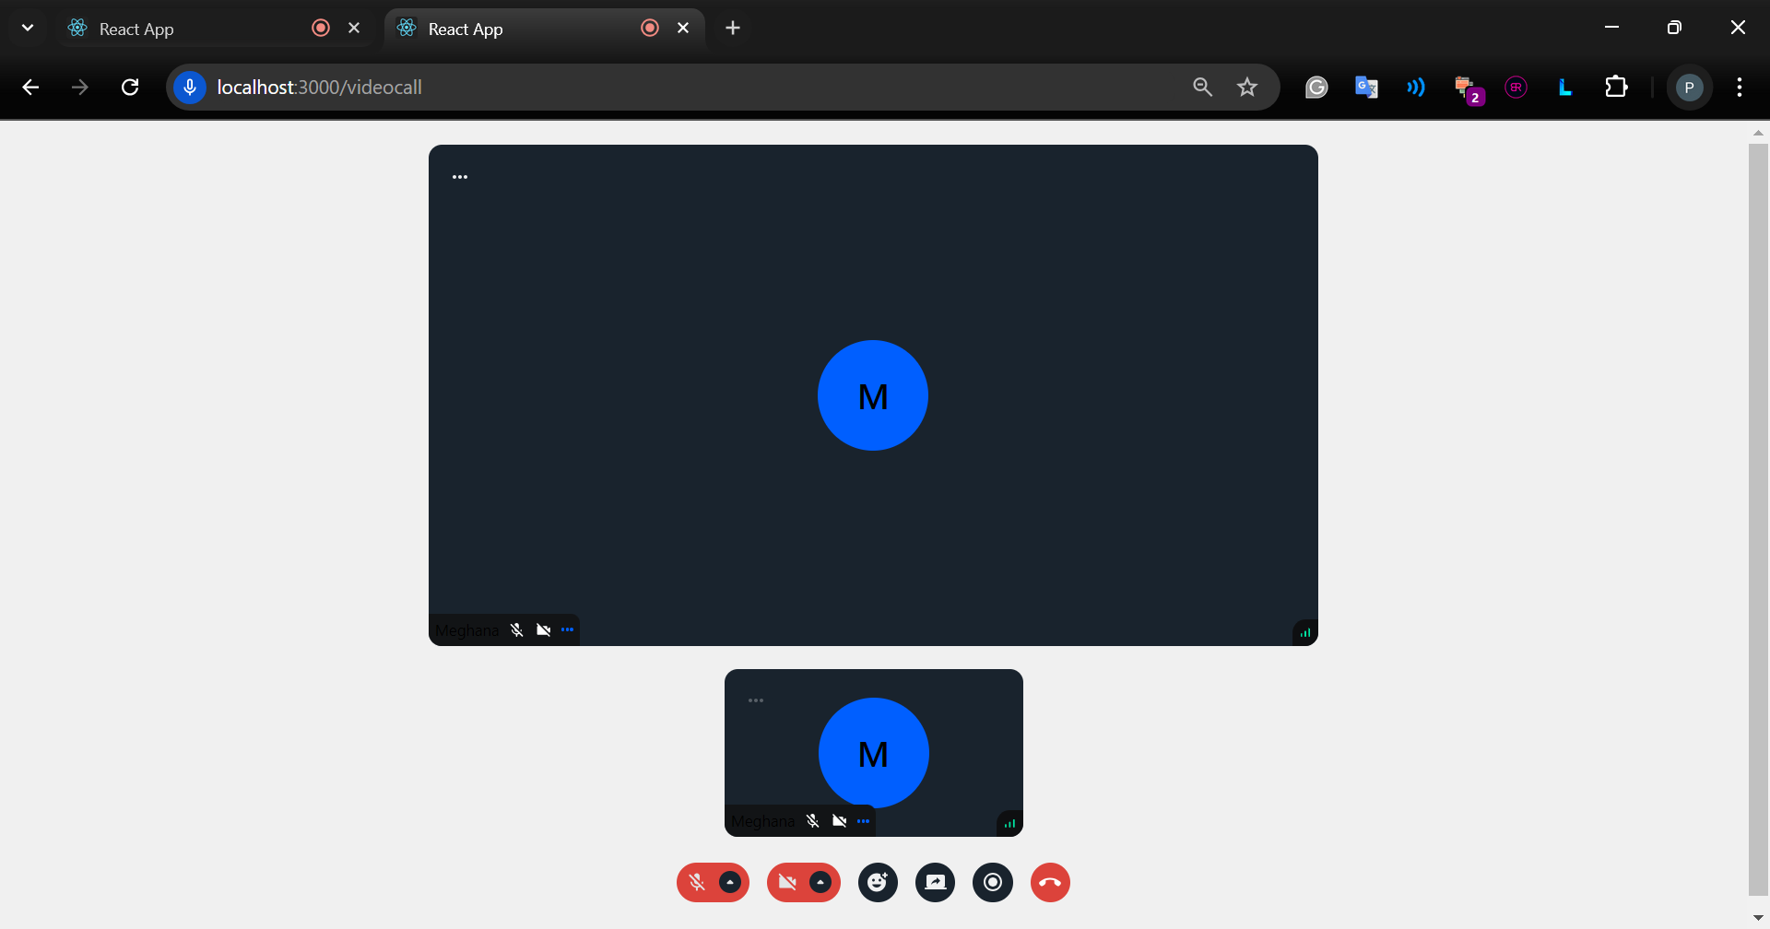

**25**

**27. Emergency chatbot**

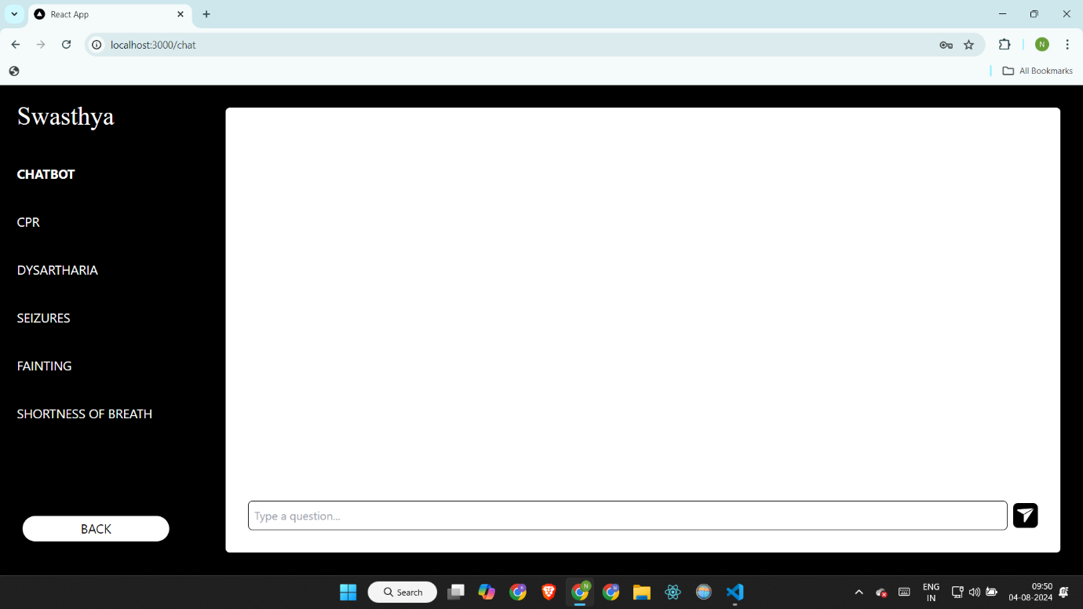

**28. CPR**

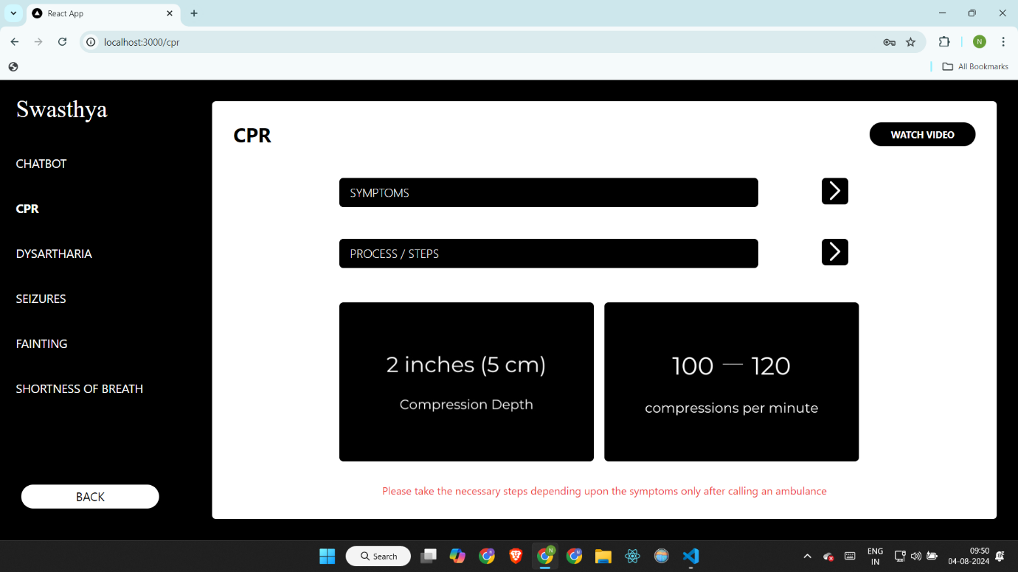

**26**

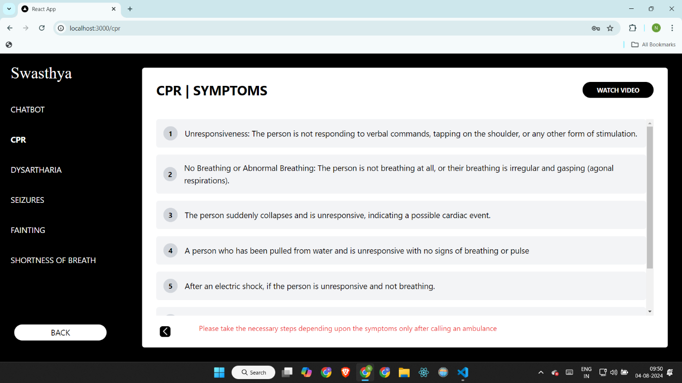

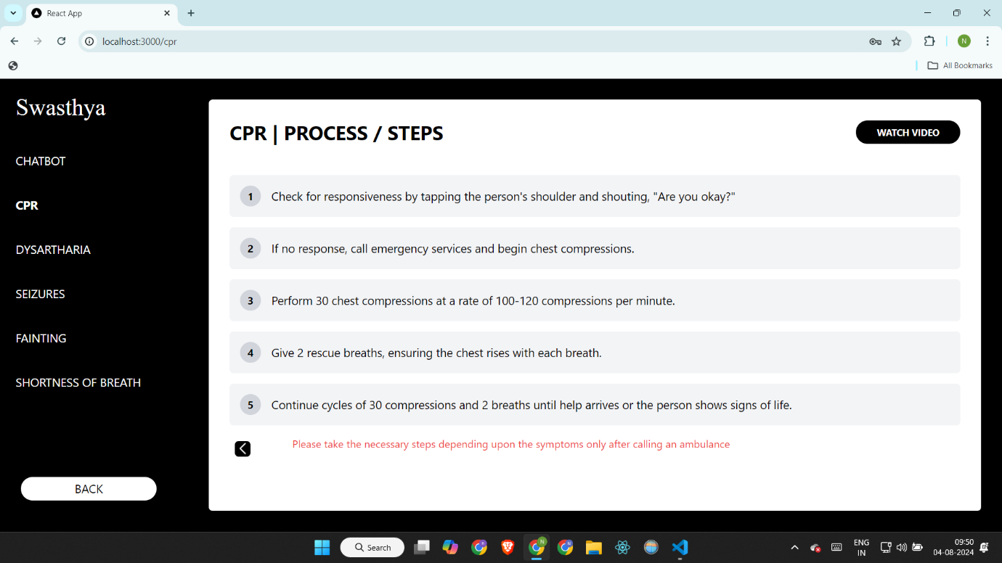

**27**

**29. Dysarthria**

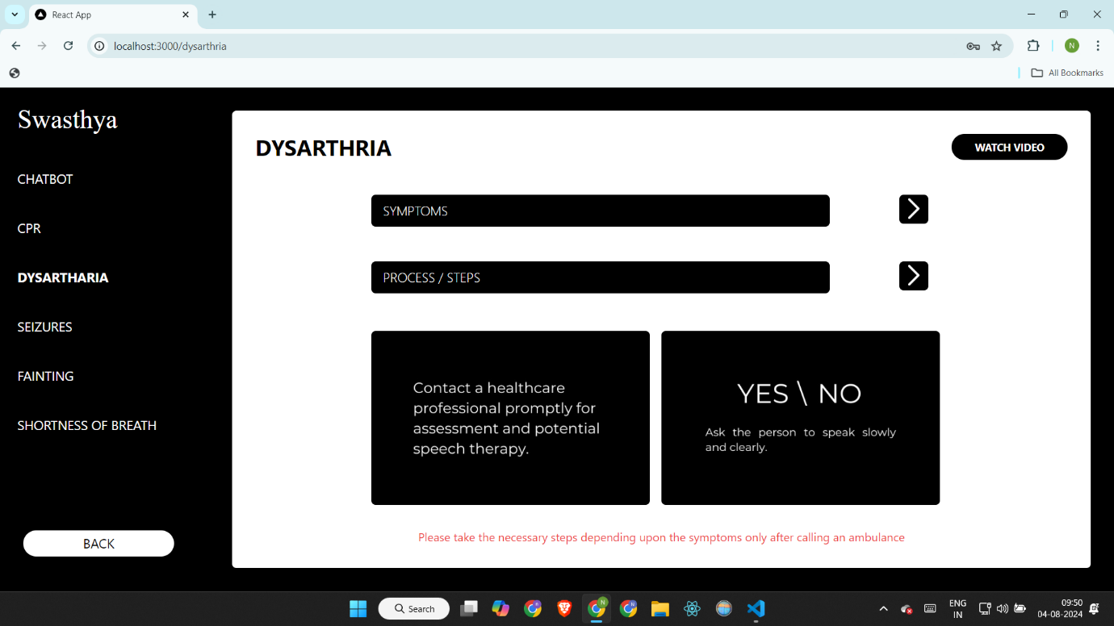

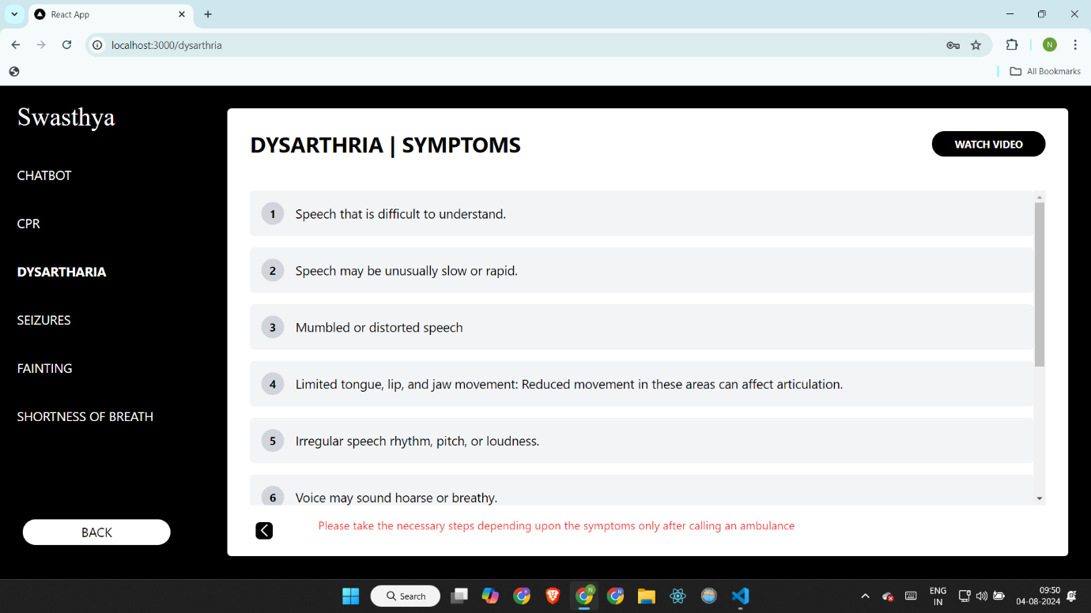

**28**

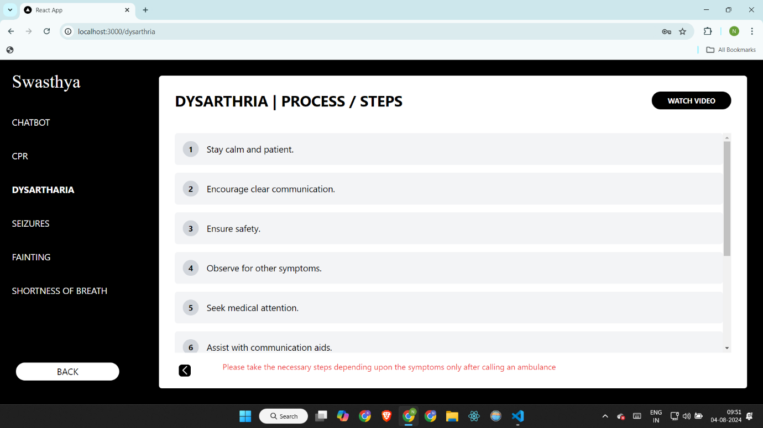

**30. Seizures**

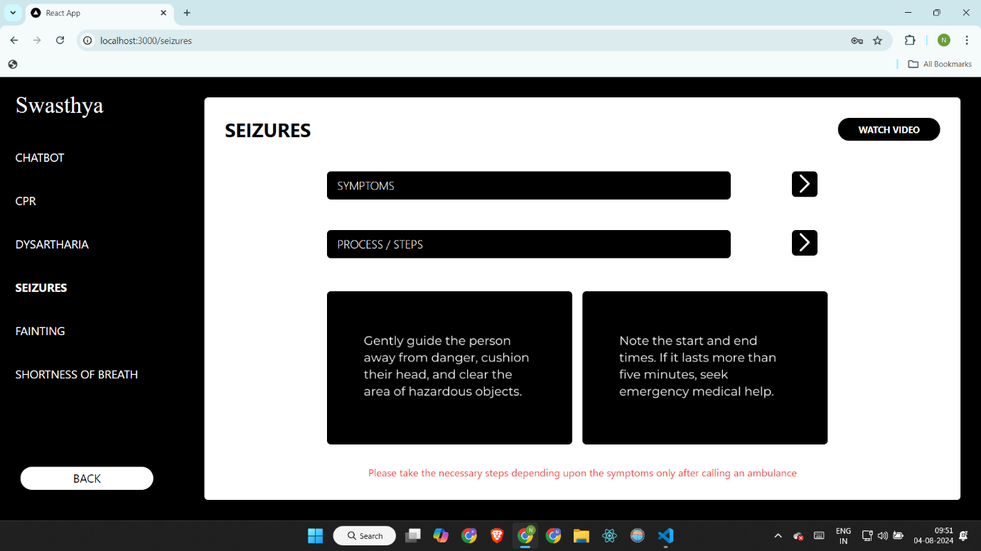

**29**

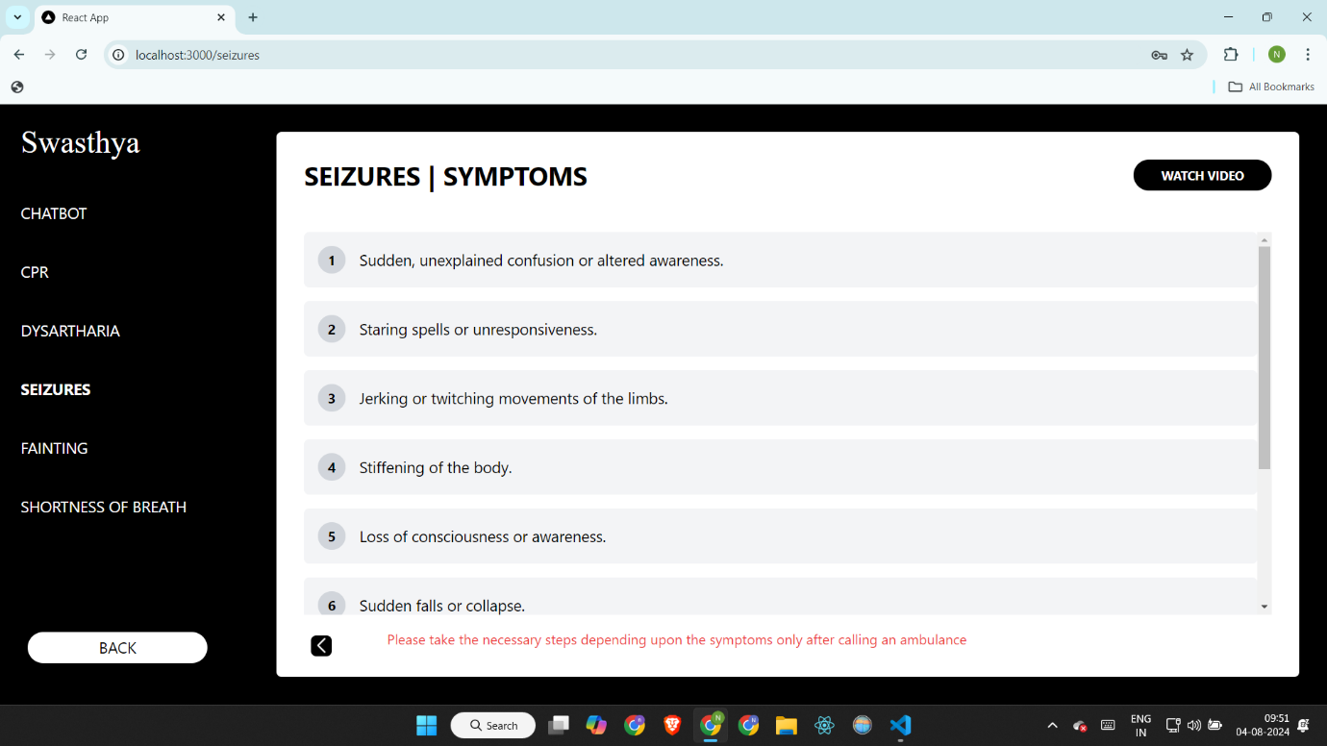

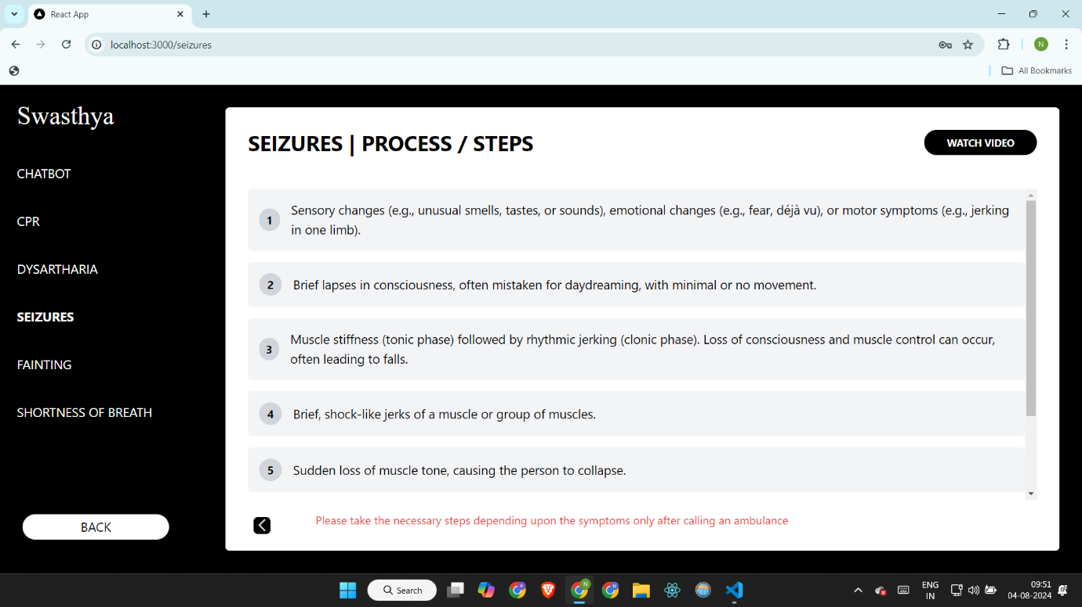

**30**

**31. Fainting**

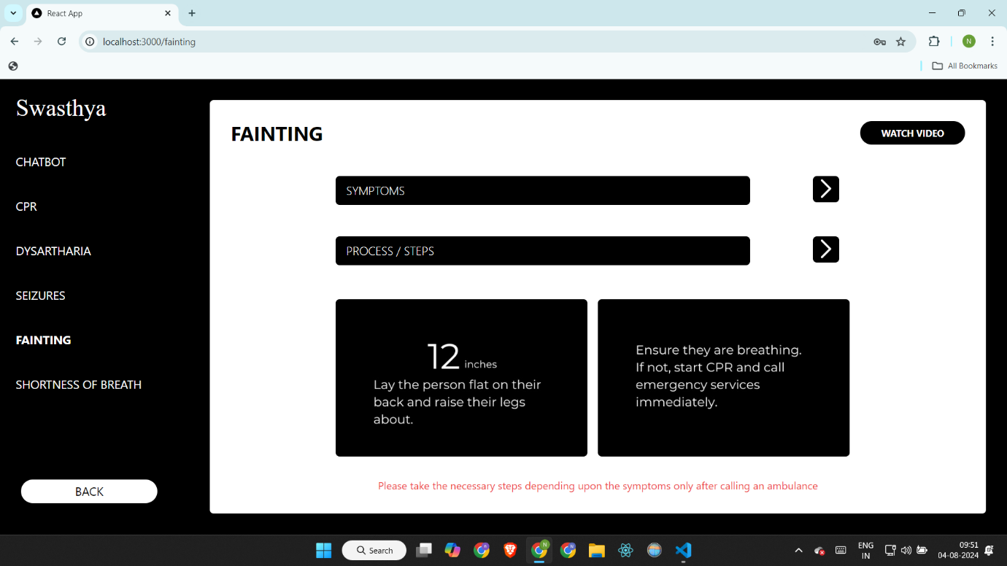

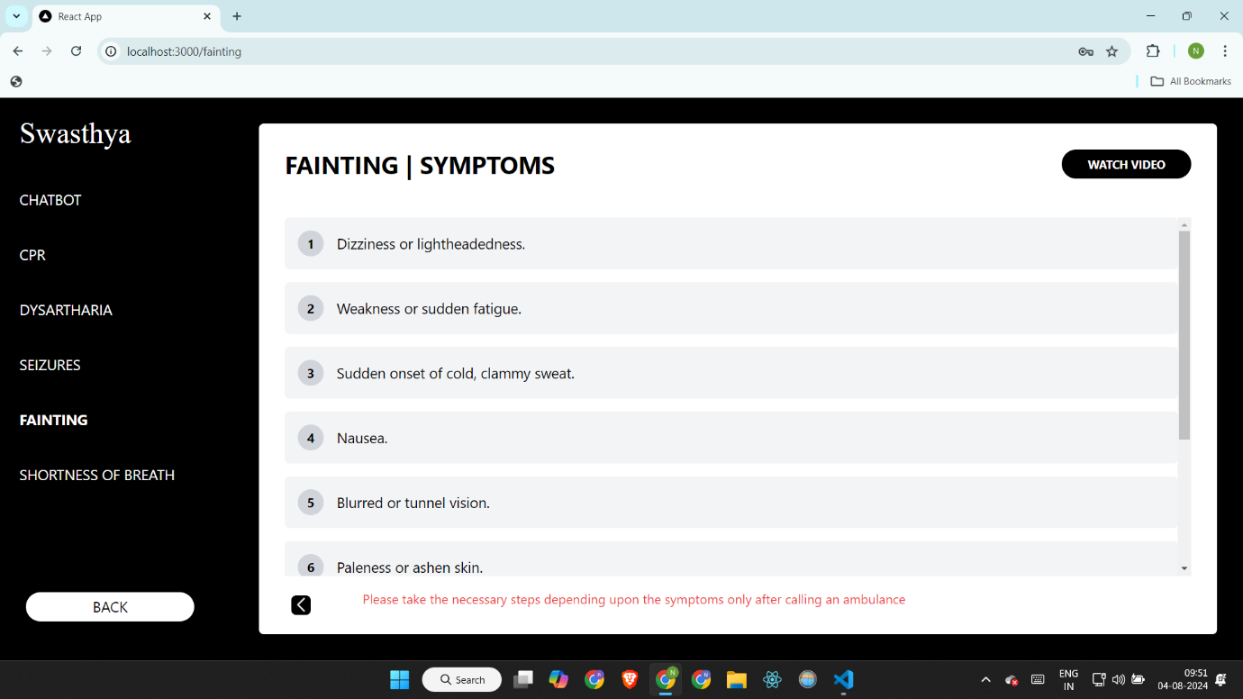

**31**

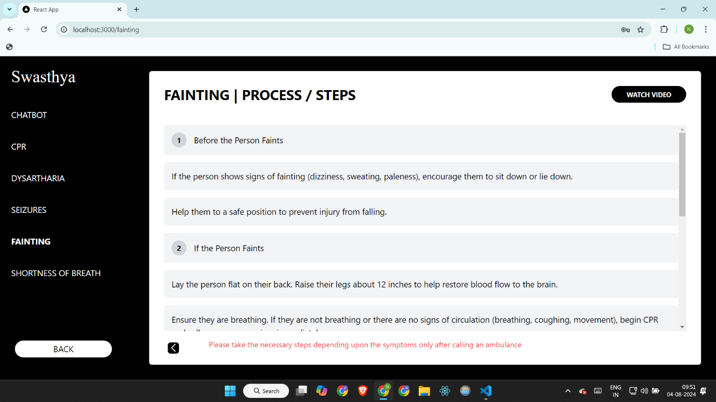

**32. Shortness of Breath**

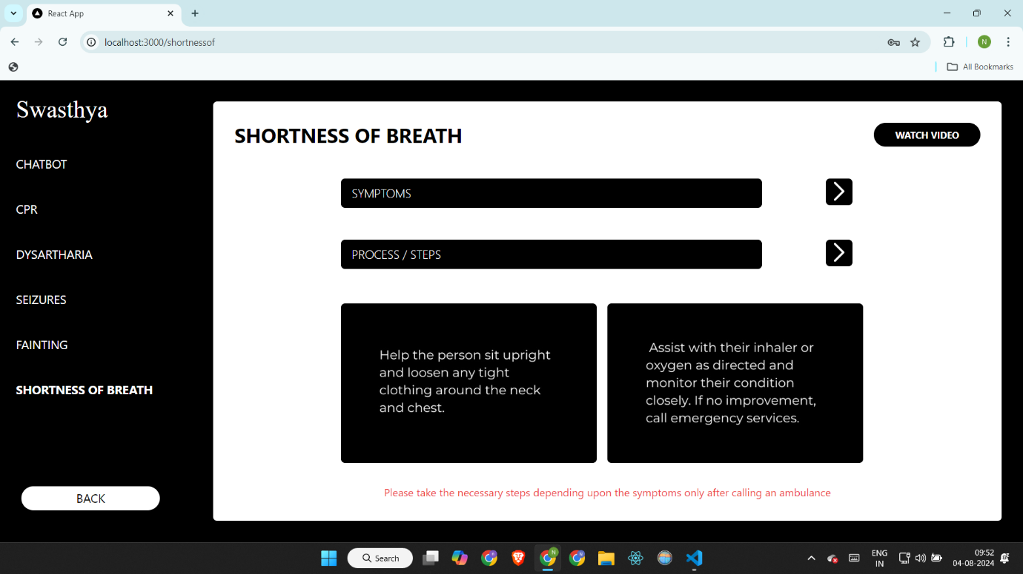

**32**

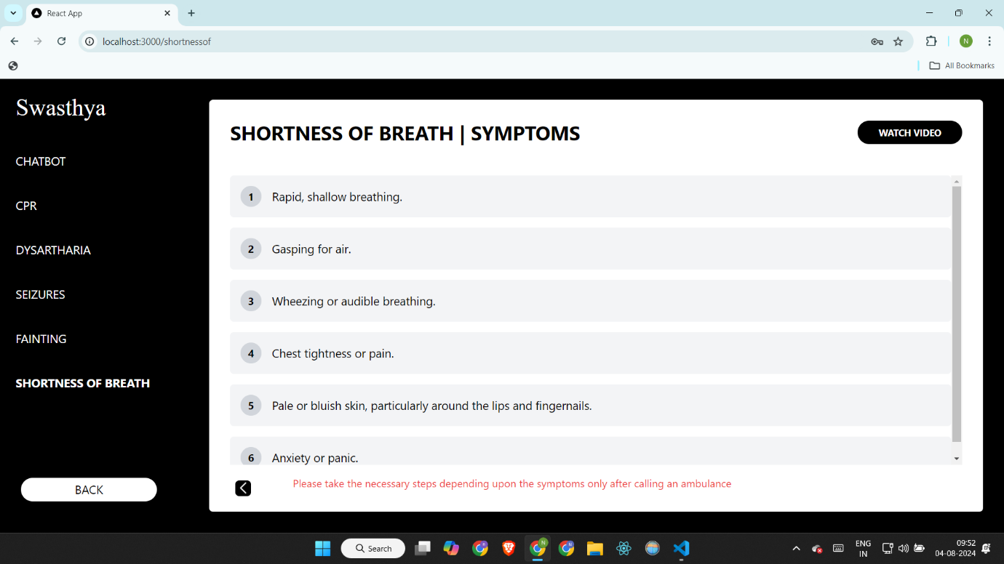

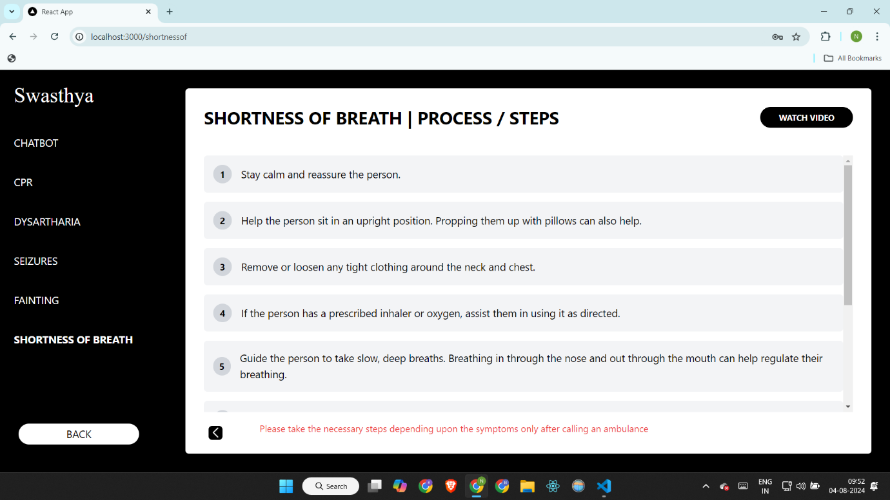

**33**

**33. After doctor login -> ward profiles**

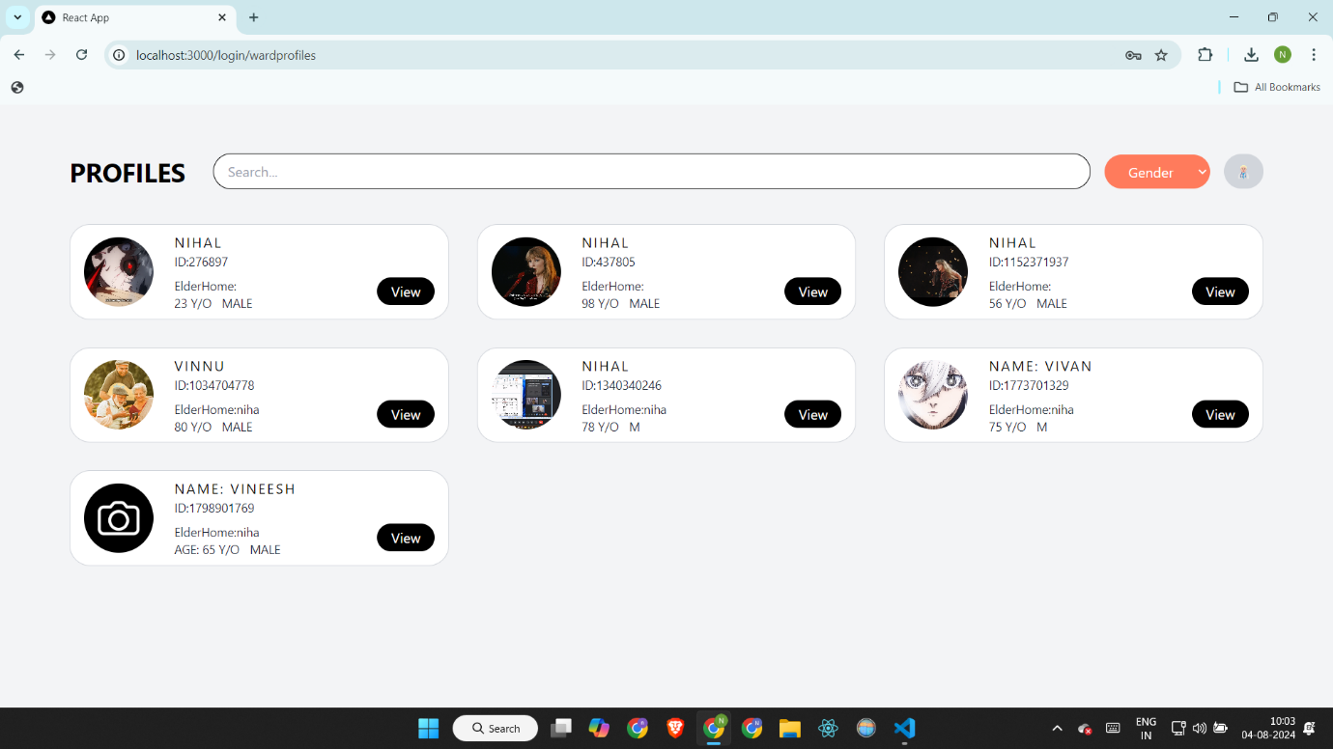**34. Doctor dashboard**

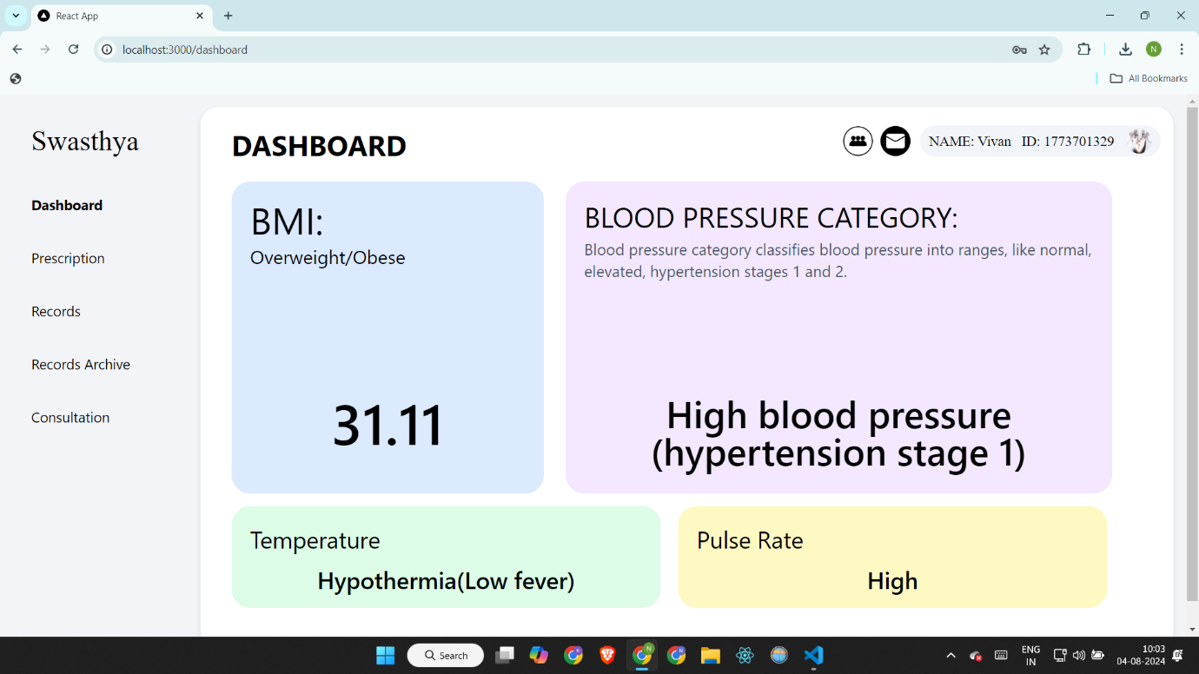

**34**

**35. Send notification**

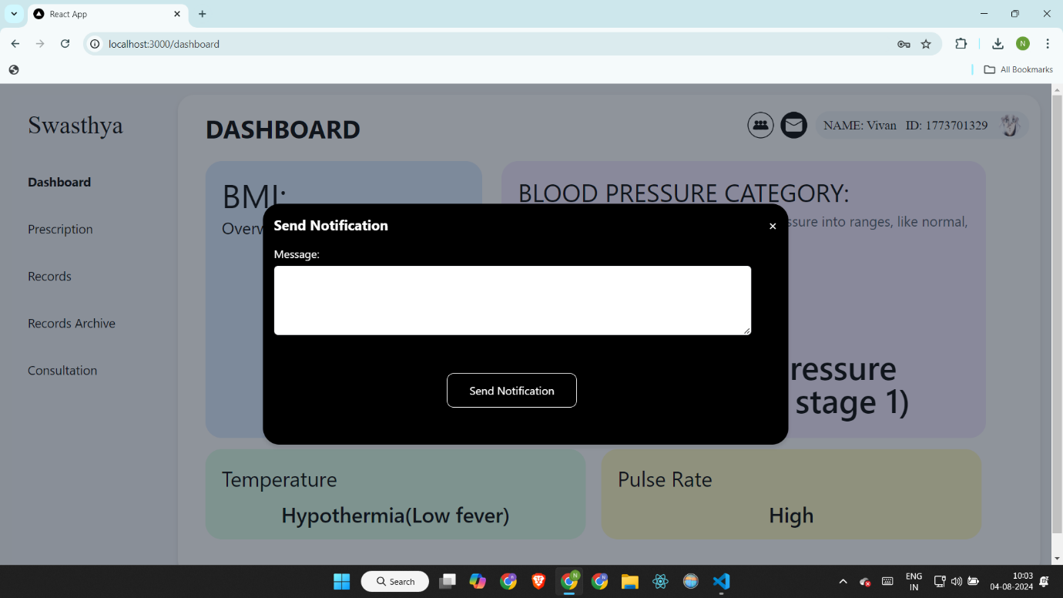

**36. Uplaod prescription**

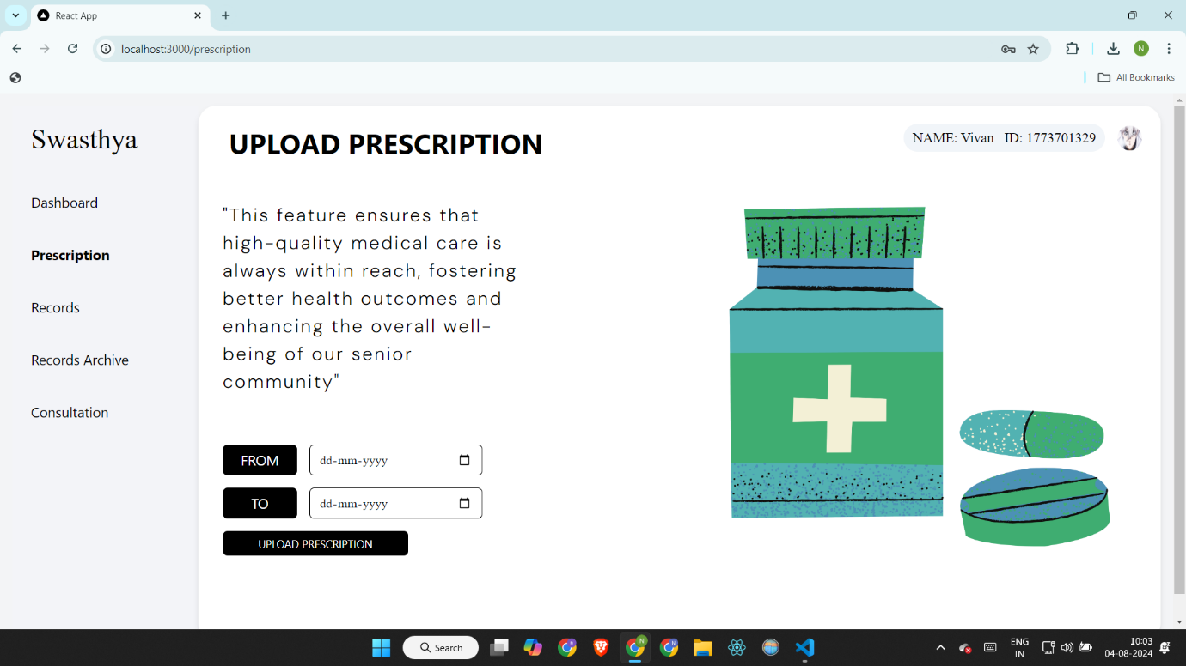

**35**

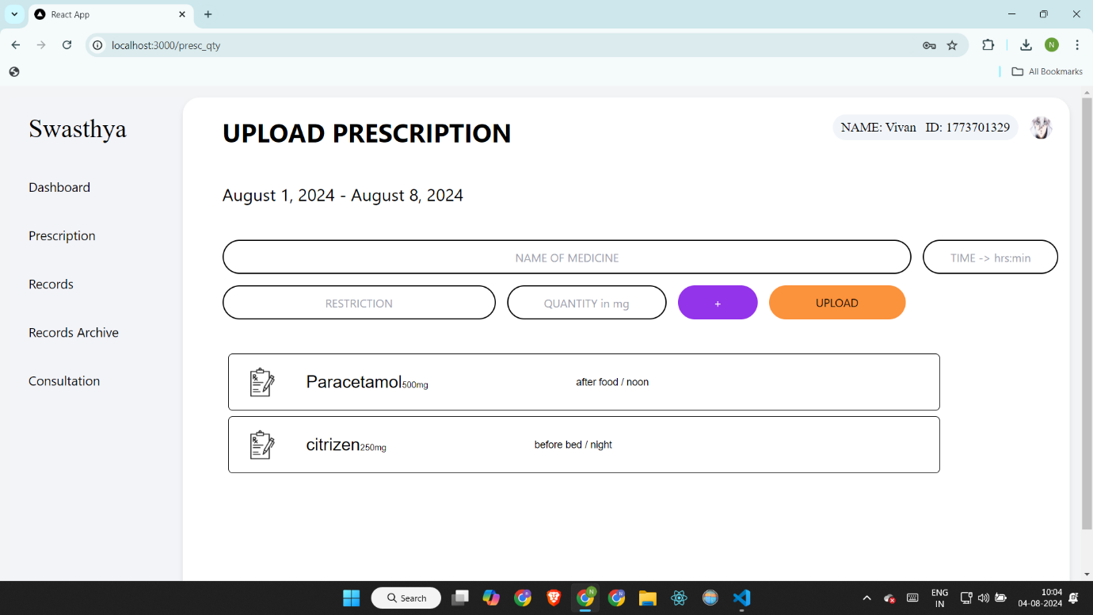

**37. View records/reports uploaded by elderhome**

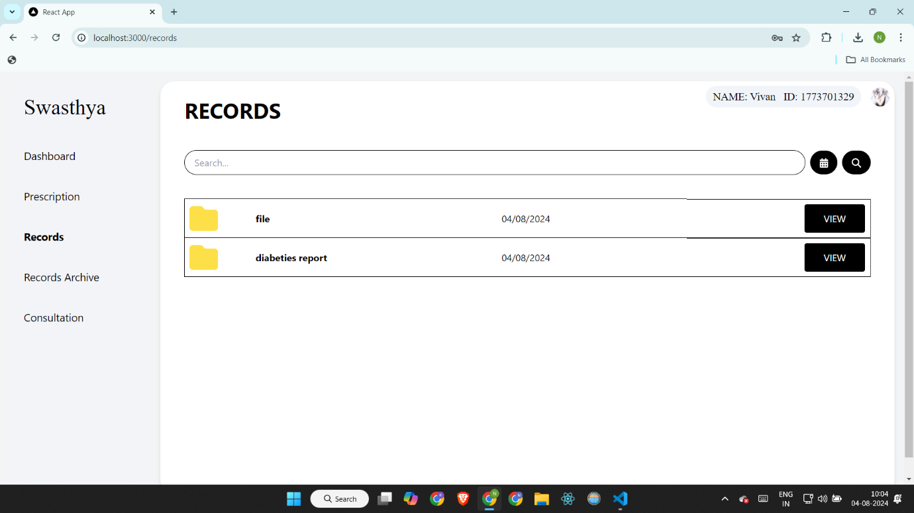

**36**

**38. Records archive ( AI analysis results archive)**

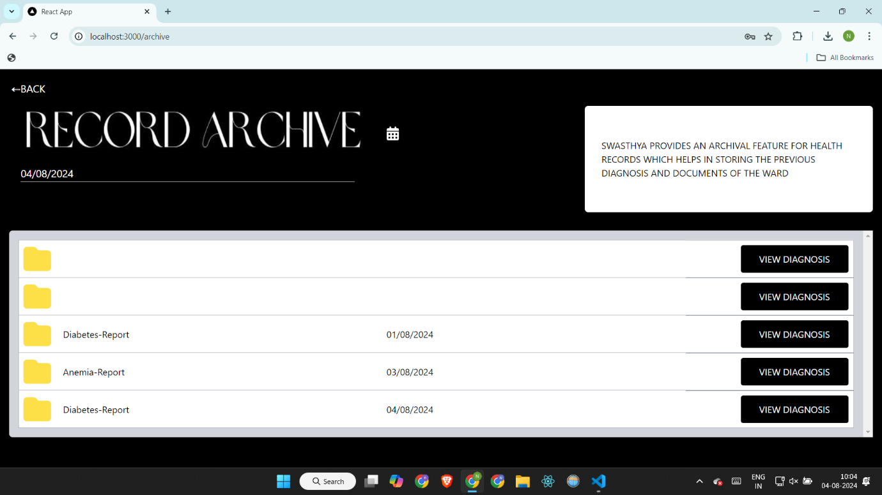

**39. Consultation**



**37**



**38**

**CONCLUSION**

In conclusion, our elder healthcare management system leverages cutting-edge Machine Learning (ML) and Language Models (LLMs) to address the growing needs of an aging population. By enabling caretakers to manage ward profiles, upload and monitor health records, and facilitate video consultations, we ensure that elderly patients receive personalized and consistent care. The integration of AI-driven diagnosis and emergency support further enhances the quality of healthcare provided.

This innovative approach not only streamlines the caregiving process but also empowers doctors to offer timely interventions through prescription monitoring and record archiving. Our system bridges the gap between traditional healthcare and the evolving needs of elderly patients, promoting better health outcomes and a higher quality of life. Through this project, we are committed to making elder care more proactive, responsive, and compassionate, ultimately supporting the well-being of elderly individuals in our community.

**39**

**FUTURE SCOPE**

1. Adding the guardian of the patients as one user, so in total this website will have 3 users
2. **Integration with Wearable Devices**:

* Incorporate data from wearable health devices (e.g., fitness trackers, smartwatches) to provide real-time health monitoring and alerts.
* Continuous tracking of vital signs such as heart rate, sleep patterns, and physical activity levels.

1. **Advanced Predictive Analytics**:

* Develop advanced predictive models using machine learning and deep learning techniques to identify early signs of diseases and potential health risks.
* Implement personalized health risk assessments based on historical data and lifestyle factors.

1. **Natural Language Processing (NLP) Enhancements**:

* Enhance the NLP capabilities to understand and process unstructured data such as doctor's notes, patient feedback, and historical health records.
* Implement conversational AI for automated patient support and query resolution.

1. **Integration with Electronic Health Records (EHR) Systems**:

* Enable seamless integration with existing EHR systems to synchronize patient data across multiple healthcare providers.
* Facilitate data exchange between different healthcare facilities for comprehensive patient care.

**40**

**REFERENCES**

1. Stackoverflow -- <https://stackoverflow.com>
2. Chatgpt -- <https://chatgpt.com>
3. Google – <https://google.in>
4. Hugging face -- <https://huggingface.co/>
5. Ollama -- <https://ollama.com/>
6. Stream.io – <https://www.getstream.io>
7. Scikit learn -- <https://scikit-learn.org/>
8. Flask -- <https://flask.palletsprojects.com/>
9. ieexplore -- <https://ieeexplore.ieee.org/document/10250703>
10. Scihub -- <https://sci-hub.se/>

**41**